






Receive and place incoming telephone calls
D1.HFO.CL2.09
Trainer Guide

Receive and place incoming telephone calls

D1.HFO.CL2.09

Trainer Guide




Project Base
William Angliss Institute of TAFE
555 La Trobe Street
Melbourne 3000 Victoria
Telephone: | (03) 9606 2111
Facsimile: | (03) 9670 1330
Acknowledgements
Project Director: | Wayne Crosbie
Chief Writer: | Alan Hickman
Subject Writers: | Evelyn Collins, Linda Wilson
Project Manager/Editor: | Alan Maguire
DTP/Production: | Daniel Chee, Mai Vu, Jirayu Thangcharoensamut, Kaly Quach

The Association of Southeast Asian Nations (ASEAN) was established on 8 August 1967. The Member States of the Association are Brunei Darussalam, Cambodia, Indonesia, Lao PDR, Malaysia, Myanmar, Philippines, Singapore, Thailand and Viet Nam.
The ASEAN Secretariat is based in Jakarta, Indonesia.
General Information on ASEAN appears online at the ASEAN Website: www.asean.org.
All text is produced by William Angliss Institute of TAFE for the ASEAN Project on “Toolbox Development for Front Office, Food and Beverage Services and Food Production Divisions”.
This publication is supported by the Australian Government’s aid program through the ASEAN-Australia Development Cooperation Program Phase II (AADCP II).
Copyright: Association of Southeast Asian Nations (ASEAN) 2013.
All rights reserved.
Disclaimer
Every effort has been made to ensure that this publication is free from errors or omissions. However, you should conduct your own enquiries and seek professional advice before relying on any fact, statement or matter contained in this book. The ASEAN Secretariat and William Angliss Institute of TAFE are not responsible for any injury, loss or damage as a result of material included or omitted from this course. Information in this module is current at the time of publication. Time of publication is indicated in the date stamp at the bottom of each page.
Some images appearing in this resource have been purchased from stock photography suppliers Shutterstock and iStockphoto and other third party copyright owners and as such are non-transferable and non-exclusive. Clip arts, font images and illustrations used are from the Microsoft Office Clip Art and Media Library. Some images have been provided by and are the property of William Angliss Institute.
Additional images have been sourced from Flickr and SXC and are used under Creative Commons licence: http://creativecommons.org/licenses/by/2.0/deed.en
File name: TG_Receive_&_place_incoming_calls_refined.docx





Table of contents
Competency Based Training (CBT) and assessment – An introduction for trainers 1
Competency standard 11
Notes and PowerPoint slides 23
Recommended training equipment 81
Instructions for Trainers for using PowerPoint – Presenter View 83
Appendix – ASEAN acronyms 85

Competency Based Training (CBT) and assessment – An introduction for trainers

Competency
Competency refers to the ability to perform particular tasks and duties to the standard of performance expected in the workplace.
Competency requires the application of specified knowledge, skills and attitudes relevant to effective participation, consistently over time and in the workplace environment.
The essential skills and knowledge are either identified separately or combined.
Knowledge identifies what a person needs to know to perform the work in an informed and effective manner.
Skills describe the application of knowledge to situations where understanding is converted into a workplace outcome.
Attitude describes the founding reasons behind the need for certain knowledge or why skills are performed in a specified manner.
Competency covers all aspects of workplace performance and involves:
- Performing individual tasks
- Managing a range of different tasks
- Responding to contingencies or breakdowns
- Dealing with the responsibilities of the workplace
- Working with others.

Unit of Competency
Like with any training qualification or program, a range of subject topics are identified that focus on the ability in a certain work area, responsibility or function.
Each manual focuses on a specific unit of competency that applies in the hospitality workplace.
In this manual a unit of competency is identified as a ‘unit’.
Each unit of competency identifies a discrete workplace requirement and includes:
- Knowledge and skills that underpin competency
- Language, literacy and numeracy
- Occupational safety and health requirements.
Each unit of competency must be adhered to in training and assessment to ensure consistency of outcomes.

Element of Competency
An element of competency describes the essential outcomes within a unit of competency.
The elements of competency are the basic building blocks of the unit of competency. They describe in terms of outcomes the significant functions and tasks that make up the competency.
In this manual elements of competency are identified as an ‘element’.

Performance criteria
Performance criteria indicate the standard of performance that is required to demonstrate achievement within an element of competency. The standards reflect identified industry skill needs.
Performance criteria will be made up of certain specified skills, knowledge and attitudes.

Learning
For the purpose of this manual learning incorporates two key activities:
- Training
- Assessment.
Both of these activities will be discussed in detail in this introduction.
Today training and assessment can be delivered in a variety of ways. It may be provided to participants:
- On-the-job – in the workplace
- Off-the-job – at an educational institution or dedicated training environment
- As a combination of these two options.
No longer is it necessary for learners to be absent from the workplace for long periods of time in order to obtain recognised and accredited qualifications.

Learning Approaches
This manual will identify two avenues to facilitate learning:
Competency Based Training (CBT)
This is the strategy of developing a participant’s competency.
Educational institutions utilise a range of training strategies to ensure that participants are able to gain the knowledge and skills required for successful:
- Completion of the training program or qualification
- Implementation in the workplace.
The strategies selected should be chosen based on suitability and the learning styles of participants.

Competency Based Assessment (CBA)
This is the strategy of assessing competency of a participant.
Educational institutions utilise a range of assessment strategies to ensure that participants are assessed in a manner that demonstrates validity, fairness, reliability, flexibility and fairness of assessment processes.

Flexibility in Learning
It is important to note that flexibility in training and assessment strategies is required to meet the needs of participants who may have learning difficulties. The strategies used will vary, taking into account the needs of individual participants with learning difficulties. However they will be applied in a manner which does not discriminate against the participant or the participant body as a whole.
Catering for Participant Diversity
Participants have diverse backgrounds, needs and interests. When planning training and assessment activities to cater for individual differences, trainers and assessors should:
- Consider individuals’ experiences, learning styles and interests
- Develop questions and activities that are aimed at different levels of ability
- Modify the expectations for some participants
- Provide opportunities for a variety of forms of participation, such as individual, pair and small group activities
- Assess participants based on individual progress and outcomes.
The diversity among participants also provides a good reason for building up a learning community in which participants support each other’s learning.
Participant Centred Learning
This involves taking into account structuring training and assessment that:
- Builds on strengths – Training environments need to demonstrate the many positive features of local participants (such as the attribution of academic success to effort, and the social nature of achievement motivation) and of their trainers (such as a strong emphasis on subject disciplines and moral responsibility). These strengths and uniqueness of local participants and trainers should be acknowledged and treasured
- Acknowledges prior knowledge and experience – The learning activities should be planned with participants’ prior knowledge and experience in mind
- Understands learning objectives – Each learning activity should have clear learning objectives and participants should be informed of them at the outset. Trainers should also be clear about the purpose of assignments and explain their significance to participants
- Teaches for understanding – The pedagogies chosen should aim at enabling participants to act and think flexibly with what they know
- Teaches for independent learning – Generic skills and reflection should be nurtured through learning activities in appropriate contexts of the curriculum. Participants should be encouraged to take responsibility for their own learning
- Enhances motivation – Learning is most effective when participants are motivated. Various strategies should be used to arouse the interest of participants
- Makes effective use of resources – A variety of teaching resources can be employed as tools for learning
- Maximises engagement – In conducting learning activities, it is important for the minds of participants to be actively engaged
- Aligns assessment with learning and teaching – Feedback and assessment should be an integral part of learning and teaching
- Caters for learner diversity – Trainers should be aware that participants have different characteristics and strengths and try to nurture these rather than impose a standard set of expectations.
Active Learning
The goal of nurturing independent learning in participants does not imply that they always have to work in isolation or solely in a classroom. On the contrary, the construction of knowledge in tourism and hospitality studies can often best be carried out in collaboration with others in the field. Sharing experiences, insights and views on issues of common concern, and working together to collect information through conducting investigative studies in the field (active learning) can contribute a lot to their eventual success.
Active learning has an important part to play in fostering a sense of community in the class. First, to operate successfully, a learning community requires an ethos of acceptance and a sense of trust among participants, and between them and their trainers. Trainers can help to foster acceptance and trust through encouragement and personal example, and by allowing participants to take risks as they explore and articulate their views, however immature these may appear to be. Participants also come to realise that their classmates (and their trainers) are partners in learning and solving.
Trainers can also encourage cooperative learning by designing appropriate group learning tasks, which include, for example, collecting background information, conducting small-scale surveys, or producing media presentations on certain issues and themes. Participants need to be reminded that, while they should work towards successful completion of the field tasks, developing positive peer relationships in the process is an important objective of all group work.

Competency Based Training (CBT)
Principle of Competency Based Training
Competency based training is aimed at developing the knowledge, skills and attitudes of participants, through a variety of training tools.
Training Strategies
The aims of this curriculum are to enable participants to:
- Undertake a variety of subject courses that are relevant to industry in the current environment
- Learn current industry skills, information and trends relevant to industry
- Learn through a range of practical and theoretical approaches
- Be able to identify, explore and solve issues in a productive manner
- Be able to become confident, equipped and flexible managers of the future
- Be ‘job ready’ and a valuable employee in the industry upon graduation of any qualification level.
To ensure participants are able to gain the knowledge and skills required to meet competency in each unit of competency in the qualification, a range of training delivery modes are used.
Types of Training
In choosing learning and teaching strategies, trainers should take into account the practical, complex and multi-disciplinary nature of the subject area, as well as their participant’s prior knowledge, learning styles and abilities.
Training outcomes can be attained by utilising one or more delivery methods:
Lecture/Tutorial
This is a common method of training involving transfer of information from the trainer to the participants. It is an effective approach to introduce new concepts or information to the learners and also to build upon the existing knowledge. The listener is expected to reflect on the subject and seek clarifications on the doubts.
Demonstration
Demonstration is a very effective training method that involves a trainer showing a participant how to perform a task or activity. Through a visual demonstration, trainers may also explain reasoning behind certain actions or provide supplementary information to help facilitate understanding.
Group Discussions
Brainstorming in which all the members in a group express their ideas, views and opinions on a given topic. It is a free flow and exchange of knowledge among the participants and the trainer. The discussion is carried out by the group on the basis of their own experience, perceptions and values. This will facilitate acquiring new knowledge. When everybody is expected to participate in the group discussion, even the introverted persons will also get stimulated and try to articulate their feelings.
The ideas that emerge in the discussions should be noted down and presentations are to be made by the groups. Sometimes consensus needs to be arrived at on a given topic. Group discussions are to be held under the moderation of a leader guided by the trainer. Group discussion technique triggers thinking process, encourages interactions and enhances communication skills.
Role Play
This is a common and very effective method of bringing into the classroom real life situations, which may not otherwise be possible. Participants are made to enact a particular role so as to give a real feel of the roles they may be called upon to play. This enables participants to understand the behaviour of others as well as their own emotions and feelings. The instructor must brief the role players on what is expected of them. The role player may either be given a ready-made script, which they can memorize and enact, or they may be required to develop their own scripts around a given situation. This technique is extremely useful in understanding creative selling techniques and human relations. It can be entertaining and energizing and it helps the reserved and less literate to express their feelings.

Simulation Games
When trainees need to become aware of something that they have not been conscious of, simulations can be a useful mechanism. Simulation games are a method based on "here and now" experience shared by all the participants. The games focus on the participation of the trainees and their willingness to share their ideas with others. A "near real life" situation is created providing an opportunity to which they apply themselves by adopting certain behaviour. They then experience the impact of their behaviour on the situation. It is carried out to generate responses and reactions based on the real feelings of the participants, which are subsequently analysed by the trainer.
While use of simulation games can result in very effective learning, it needs considerable trainer competence to analyse the situations.
Individual /Group Exercises
Exercises are often introduced to find out how much the participant has assimilated. This method involves imparting instructions to participants on a particular subject through use of written exercises. In the group exercises, the entire class is divided into small groups, and members are asked to collaborate to arrive at a consensus or solution to a problem.
Case Study
This is a training method that enables the trainer and the participant to experience a real life situation. It may be on account of events in the past or situations in the present, in which there may be one or more problems to be solved and decisions to be taken. The basic objective of a case study is to help participants diagnose, analyse and/or solve a particular problem and to make them internalize the critical inputs delivered in the training. Questions are generally given at the end of the case study to direct the participants and to stimulate their thinking towards possible solutions. Studies may be presented in written or verbal form.
Field Visit
This involves a carefully planned visit or tour to a place of learning or interest. The idea is to give first-hand knowledge by personal observation of field situations, and to relate theory with practice. The emphasis is on observing, exploring, asking questions and understanding. The trainer should remember to brief the participants about what they should observe and about the customs and norms that need to be respected.
Group Presentation
The participants are asked to work in groups and produce the results and findings of their group work to the members of another sub-group. By this method participants get a good picture of each other's views and perceptions on the topic and they are able to compare them with their own point of view. The pooling and sharing of findings enriches the discussion and learning process.
Practice Sessions
This method is of paramount importance for skills training. Participants are provided with an opportunity to practice in a controlled situation what they have learnt. It could be real life or through a make-believe situation.

Games
This is a group process and includes those methods that involve usually fun-based activity, aimed at conveying feelings and experiences, which are everyday in nature, and applying them within the game being played. A game has set rules and regulations, and may or may not include a competitive element. After the game is played, it is essential that the participants be debriefed and their lessons and experiences consolidated by the trainer.
Research
Trainers may require learners to undertake research activities, including online research, to gather information or further understanding about a specific subject area.

Competency Based Assessment (CBA)
Principle of Competency Based Assessment
Competency based assessment is aimed at compiling a list of evidence that shows that a person is competent in a particular unit of competency.
Competencies are gained through a multitude of ways including:
- Training and development programs
- Formal education
- Life experience
- Apprenticeships
- On-the-job experience
- Self-help programs.
All of these together contribute to job competence in a person. Ultimately, assessors and participants work together, through the ‘collection of evidence’ in determining overall competence.
This evidence can be collected:
- Using different formats
- Using different people
- Collected over a period of time.
The assessor who is ideally someone with considerable experience in the area being assessed, reviews the evidence and verifies the person as being competent or not.
Flexibility in Assessment
Whilst allocated assessment tools have been identified for this subject, all attempts are made to determine competency and suitable alternate assessment tools may be used, according to the requirements of the participant.
The assessment needs to be equitable for all participants, taking into account their cultural and linguistic needs.
Competency must be proven regardless of:
- Language
- Delivery Method
- Assessment Method.
Assessment Objectives
The assessment tools used for subjects are designed to determine competency against the ‘elements of competency’ and their associated ‘performance criteria’.
The assessment tools are used to identify sufficient:
- Knowledge, including underpinning knowledge
- Skills
- Attitudes
Assessment tools are activities that trainees are required to undertake to prove participant competency in this subject.
All assessments must be completed satisfactorily for participants to obtain competence in this subject. There are no exceptions to this requirement, however, it is possible that in some cases several assessment items may be combined and assessed together.
Types of Assessment
Allocated Assessment Tools
There are a number of assessment tools that are used to determine competency in this subject:
- Work projects
- Written questions
- Oral questions
- Third Party Report
- Observation Checklist.
Instructions on how assessors should conduct these assessment methods are explained in the Assessment Manuals.
Alternative Assessment Tools
Whilst this subject has identified assessment tools, as indicated above, this does not restrict the assessor from using different assessment methods to measure the competency of a participant.
Evidence is simply proof that the assessor gathers to show participants can actually do what they are required to do.
Whilst there is a distinct requirement for participants to demonstrate competency, there are many and diverse sources of evidence available to the assessor.
Ongoing performance at work, as verified by a supervisor or physical evidence, can count towards assessment. Additionally, the assessor can talk to customers or work colleagues to gather evidence about performance.
A range of assessment methods to assess competency include:
- Practical demonstrations
- Practical demonstrations in simulated work conditions
- Problem solving
- Portfolios of evidence
- Critical incident reports
- Journals
- Oral presentations
- Interviews
- Videos
- Visuals: slides, audio tapes
- Case studies
- Log books
- Projects
- Role plays
- Group projects
- Group discussions
- Examinations.
Recognition of Prior Learning
Recognition of Prior Learning is the process that gives current industry professionals who do not have a formal qualification, the opportunity to benchmark their extensive skills and experience against the standards set out in each unit of competency/subject.
Also known as a Skills Recognition Audit (SRA), this process is a learning and assessment pathway which encompasses:
- Recognition of Current Competencies (RCC)
- Skills auditing
- Gap analysis and training
- Credit transfer.
Assessing competency
As mentioned, assessment is the process of identifying a participant’s current knowledge, skills and attitudes sets against all elements of competency within a unit of competency. Traditionally in education, grades or marks were given to participants, dependent on how many questions the participant successfully answered in an assessment tool.
Competency based assessment does not award grades, but simply identifies if the participant has the knowledge, skills and attitudes to undertake the required task to the specified standard.
Therefore, when assessing competency, an assessor has two possible results that can be awarded:
- Pass Competent (PC)
- Not Yet Competent (NYC)
- Pass Competent (PC).
If the participant is able to successfully answer or demonstrate what is required, to the expected standards of the performance criteria, they will be deemed as ‘Pass Competent’ (PC).
The assessor will award a ‘Pass Competent’ (PC) if they feel the participant has the necessary knowledge, skills and attitudes in all assessment tasks for a unit.
Not Yet Competent’ (NYC)
If the participant is unable to answer or demonstrate competency to the desired standard, they will be deemed to be ‘Not Yet Competent’ (NYC).
This does not mean the participant will need to complete all the assessment tasks again. The focus will be on the specific assessment tasks that were not performed to the expected standards.
The participant may be required to:
a) Undertake further training or instruction
b) Undertake the assessment task again until they are deemed to be ‘Pass Competent’.

Competency standard
UNIT TITLE: RECEIVE AND PLACE INCOMING TELEPHONE CALLS |  | NOMINAL HOURS: 15
UNIT NUMBER: D1.HFO.CL2.09
UNIT DESCRIPTOR: This unit deals with skills and knowledge required to receive incoming calls and to deal effectively with them by transferring and/or re-directing them, as appropriate, or by taking other suitable action within the travel industries workplace context.
ELEMENTS AND PERFORMANCE CRITERIA | UNIT VARIABLE AND ASSESSMENT GUIDE
Element 1: Identify elements and facilities of the host enterprise telephone system  - Identify the types of incoming calls that may be received and their importance to the business  - Identify the components of the telephone system  - Describe the functions and features available in the telephone system  Element 2: Demonstrate appropriate telephone communication skills  - Interpret the enterprise policies and procedures for telephone use in regard to incoming calls  - Explain the importance of first impressions in relation to telephone answering and the reputation of the business  - Differentiate between face-to-face and over-the-phone communications  - Use appropriate telephone communication skills | Unit Variables  The Unit Variables provide advice to interpret the scope and context of this unit of competence, allowing for differences between enterprises and workplaces. It relates to the unit as a whole and facilitates holistic assessment  This unit applies to all industry sectors that receive and place incoming telephone calls within the labour divisions of the hotel and travel industries and may include:  - Front Office  Types of incoming calls may be related to:  Enquire  Enquiries  Reservations  Complaints  Messages for management, staff and guests  Clarification of orders from suppliers  Return calls
- Use appropriate telephone techniques  - Describe acceptable telephone etiquette  - Identify common caller complaints about telephoning a business  Element 3: Receive incoming calls  - Prepare to receive incoming calls  - Answer calls promptly in accordance with house standards  - Identify long-distance or international calls  - Establish purpose of incoming calls  - Respond to caller requests, where appropriate  - Take messages from callers  - Relay messages and follow-up as necessary  - Facilitate conference calls  - Deal with suspicious or threatening calls  - Manage difficult callers  - Prepare voicemail messages and background music  Element 4: Re-direct incoming calls  - Transfer calls as appropriate  - Place calls on hold as appropriate | Components of the telephone system may include:  Landline telephones, including multiple lines and multiple telephone numbers  Mobile/cell phones  Paging systems  Switchboards  Handsets and headsets  Caller identification facilities, including VIP caller ID.  Functions and features available in the telephone system may be related to:  Call waiting  Call forwarding  Caller ID display  Line blocking  Call back busy  No answer, and busy-no answer  Call return  Recorded message service  Executive busy override  Transfer and transfer recall  Placing calls on hold  Multiple chat facility  Conference call  Integration of facilities.
Enterprise policies and procedures for telephone use may include:
Privacy and confidentiality issues
Response to threatening or suspicious calls
Standard greetings
Authorisation(s) to use the system and nominated elements of it
Training requirements
Stated priorities for in-person customers in relation to telephone callers.
Telephone communication skills should relate to:
Conveying a helpful and positive attitude
Using the voice effectively and appropriately given the nature of the incoming call
Applying effective listening and questioning skills
Demonstrating positive speaking skills, including clarity and the need to be concise
Responding professionally to all manner of incoming calls
Choosing appropriate tone, volume and language to use in response to each incoming call
Screening calls, as required.
Telephone techniques may include:
Clarifying caller requirements
Repeating back names, dates and times
Using the phonetic alphabet when clarifying caller details
Realising the caller cannot read your facial expressions and understand other pressures that might be applicable at the time of their call.
Telephone etiquette must address:
Courtesy, civility and respect
Reduction of background noise
Correct operation of system functions to prevent caller frustration
Using the caller’s name when known
Thanking caller
Asking caller if they would like to hold before placing them on hold
Advising caller of your intentions in respect to dealing with their call
Advising caller of the name of the person to whom their call is being directed/transferred
Apologising for delays, including never leaving a caller on hold for longer than 30 seconds without some form of contact
Allowing caller to hang up before terminating the call.
Common caller complaints may include:
Telephone rings too long before being answered
Being placed on hold for too long
Inability to get through, such as the line/number is always busy
Receptionist becomes defensive or abusive when asked for their name
Failure to determine where the call should be directed
Failure to listen
Incompetence with the system; for example, the caller is disconnected when being transferred
Lack of professionalism, including failure to place call on hold before talking to colleagues, giving an inappropriate greeting, lack of knowledge about the establishment and its staff
Improper tone of voice used by receptionist.

Prepare to receive calls may relate to:
Organising the work area
Obtaining or preparing internal telephone list, including for staff and guests
Obtaining list of internal extension numbers
Obtaining telephone system user manual/s
Eliminating distraction.
Answer calls may relate to:
Answering before house ring limit is reached
Using host enterprise standard greeting
Identifying self and enterprise, greeting caller and making an offer of assistance
Focusing and concentrating on the call
Taking notes
Identifying whether caller is calling long-distance or internationally
Identifying if caller is a designated VIP caller
Screening calls
Placing existing calls on hold to answer incoming call.
Establish purpose may include:
Clarifying caller need
Asking questions
Repeating information supplied by caller, including paraphrasing to confirm understanding
Seeking extra information.

Respond to caller requests may involve:
Answering caller queries
Seeking more information from caller
Apologising where an immediate, correct response cannot be given
Transferring call to the correct/more appropriate extension
Asking caller if they would like to hold or if they would prefer to be called back
Following-up.
Take messages should include:
Offering voicemail alternative, if applicable
Identifying who message is for
Clarifying spelling of names
Obtaining and checking relevant dates, times and numbers
Repeating back all details
Noting action required and urgency of message.
Relay messages may relate to:
Notifying person verbally
Lodging message in pigeon-hole or message book
Activating internal message waiting system
Using internal paging system
Returning to the caller to advise of progress of message.

Suspicious or threatening calls may relate to:
Capturing as much detail as possible about the call, caller and nature of the threat
Notifying management and other staff
Initiating an evacuation or implementation of the Emergency Management Plan (EMP)
Notifying relevant authorities
Assisting in calling department and room numbers to facilitate the warning of people in accordance with the Emergency Management Plan.
Difficult callers may include:
Callers using a different language
Aggressive and abusive callers
Rude and impatient callers
Intoxicated callers.
Prepare voicemail messages may relate to:
Determining the content of the message
Determining appropriate background music
Recording messages for callers who have been placed on hold
Recording messages for callers who are being transferred
Recording messages for individuals where there is no answer on the extension
Recording out of hour messages
Recording call waiting messages.

Transfer calls may include:
Determining name of caller and purpose of call
Thanking caller for the call
Advising caller of intention to transfer the call
Notifying to whom/where the call is to be transferred
Announcing call, if applicable.
Place calls on hold may include:
Advising caller of intention to place them on hold
Asking caller if they would prefer to be called back instead of being placed on hold
Thanking caller and apologising for delay
Keeping in regular contact with all on hold calls and enquiring if they are still prepared to wait.
Place calls on hold may include:
Advising caller of intention to place them on hold
Asking caller if they would prefer to be called back instead of being placed on hold
Thanking caller and apologising for delay
Keeping in regular contact with all on hold calls and enquiring if they are still prepared to wait.

Assessment Guide
The following skills and knowledge must be assessed as part of this unit:
Knowledge of the enterprise’s policies and procedures in regard to telephone operation and implementation of the Emergency Management Plan
Knowledge of the principles of telephone communication
Knowledge of the products, including knowledge about the host enterprise, staff, services offered, rates, contact details
Ability to use the host enterprise telephone systems and facilities
Ability to apply verbal communication, customer service, decision making, message taking and conflict resolution skills
Ability to cope under pressure.
Linkages To Other Units
Communicate on the telephone
Facilitate out-going phone calls
Provide information about in-house services
Provide international (IDD) service information
Develop and update local knowledge
Maintain hospitality industry knowledge
Receive and resolve customer complaints
Work effectively with colleagues and customers
Work in a socially diverse environment
Promote products and services to customers
Operate a (PABX) switchboard.
Critical Aspects of Assessment
Evidence of the following is essential:
Understanding of the functions and features of the host enterprise telephone system
Demonstrated ability to implement enterprise policies on telephone use
Demonstrated ability to answer calls and respond to a range of nominated enquiries
Demonstrated ability to transfer calls to nominated people/extensions
Demonstrated ability to place calls on hold
Demonstrated ability to record telephone voice messages
Demonstrated ability to take and effectively process telephone messages
Demonstrated ability to deal with a nominated range of suspicious, threatening and difficult telephone callers
Demonstrated ability to apply appropriate telephone techniques and etiquette.
Context of Assessment
This unit may be assessed on or off the job:
Assessment should include practical demonstration either in the workplace or through a simulation activity, supported by a range of methods to assess underpinning knowledge
Assessment must relate to the individual’s work area or area of responsibility.
Resource Implications
Training and assessment to include access to a real or simulated workplace but must include the use of a real telephone system and real callers; and access to workplace standards, procedures, policies, guidelines, tools and equipment.

Assessment Methods
The following methods may be used to assess competency for this unit:
Case studies
Observation of practical candidate performance
Oral and written questions
Portfolio evidence
Problem solving
Role plays
Third party reports completed by a supervisor
Project and assignment work.
Key Competencies in this Unit
Level 1 = competence to undertake tasks effectively
Level 2 = competence to manage tasks
Level 3 = competence to use concepts for evaluating
 | Key Competencies | Level | Examples
 | Collecting, organising and analysing information | 1 | Develop internal telephone, staff and contact lists; develop product and property knowledge
 | Communicating ideas and information | 2 | Speak with callers, determine needs and respond appropriately
 | Planning and organising activities | 1 | Prepare the area for work
 | Working with others and in teams | 2 | Liaise with others to meet stated caller needs
 | Using mathematical ideas and techniques | -
 | Solving problems | 1 | Deal with telephone complaints
 | Using technology | 2 | Operate the telephone system and its integrated elements

Notes and PowerPoint slides
Slide

Slide No | Trainer Notes
Discuss with trainees
How does the way you would speak to a customer on the telephone differ to the way you would speak to your friends or family? How many of you have ever worked in a job where you need to speak to customers on the telephone? What hints can you share with the rest of the class?

Slide
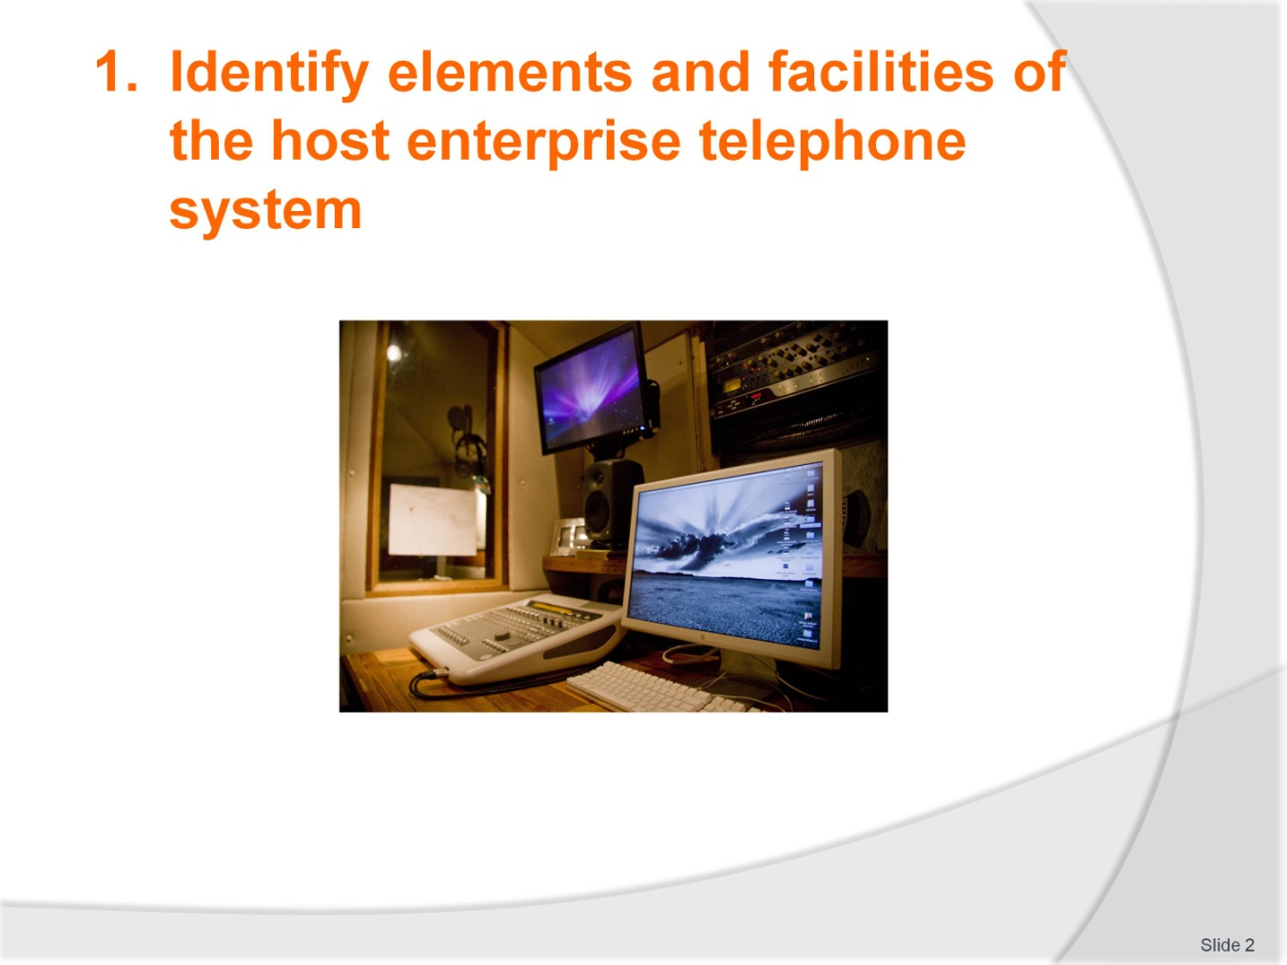
Slide No | Trainer Notes
Class discussion
How many of you have a mobile phone? Make a list of the features available on a mobile phone e.g. camera, speaker phone, call forwarding etc. Which mobile phone features would also be available on a hotel phone system and how could they be used to improve the hotel’s performance and customer service e.g. message recording. Is there a place for mobile phones in a hotel – how could they be used to improve efficiency?

Slide
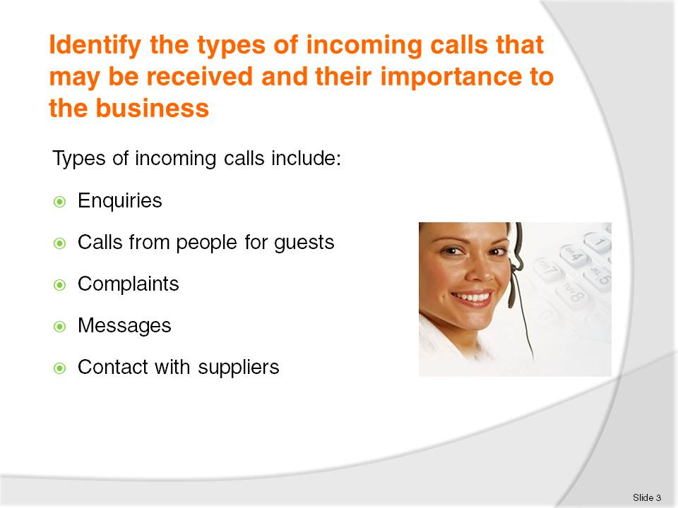
Slide No | Trainer Notes
Since the 1890s telephones have enabled instant contact with hotels for bookings and requests
The telephone plays an important role in communication with a hotel and within a hotel or resort
Incoming calls by landline and contact via mobile or cell phone, including smart phones with internet linkage, make up a high percentage of guest contact with a hotel or resort
The primary role of a receptionist or telephonist in a hotel or resort is to answer all incoming calls
Incoming calls could be from external locations or in-house guests needing assistance or asking questions or staff contacting departments
What are the types of incoming calls?
Class buzz session
Looking at a hotel and its location list as many examples of incoming calls as the class can think of e.g. suppliers, contact for orders, new product, questions about orders that have been placed by the hotel etc. customer feedback etc.
Complaints made may relate to service (too slow, not respectful), about rooms, bed comfort, bathroom cleanliness, access to pool, gym, activities etc.

Slide
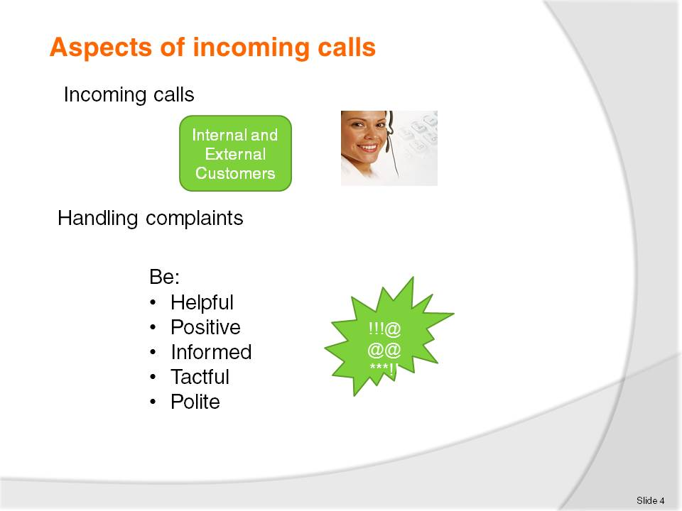
Slide No | Trainer Notes
Role play
Trainees work in pairs to practice the roles of customers and reception staff making and receiving calls. If trainees are not confident to do this immediately they can spend some time writing up a dialogue that they can then perform with each other and then perhaps for the whole class group. When performing the role with each other trainees can sit back to back on chairs and pretend to be on the phone. Otherwise they can make real calls with their mobile phones and put it on speaker phone if the demonstration is being done for the whole class.
Trainees need to act their roles carefully – the Customer needs to complain strongly or at least be clear about what they want and the hotel reception staff member needs to display the qualities of helpfulness, being positive, informed, tactful and polite.

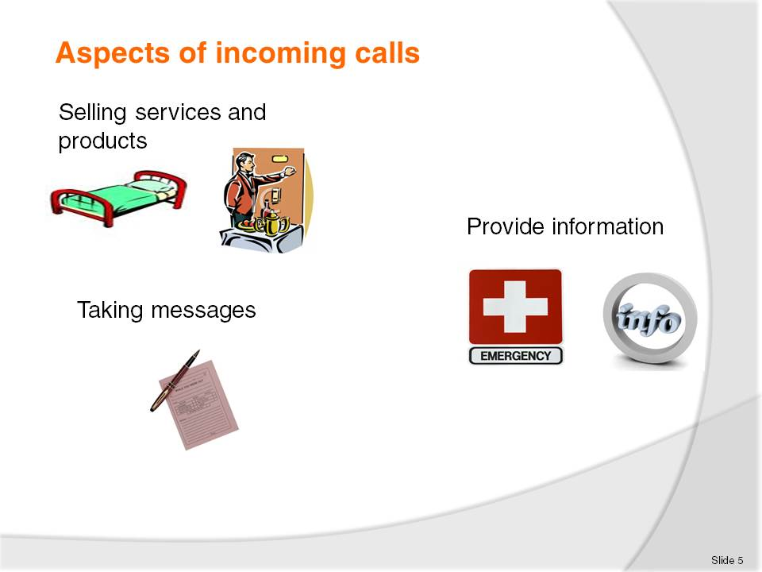
Slide No | Trainer Notes
Role play
Trainees work in pairs to practice the roles of customers and reception staff making and receiving calls. If trainees are not confident to do this immediately they can spend some time writing up a dialogue that they can then perform with each other and then perhaps for the whole class group. When performing the role with each other trainees can sit back to back on chairs and pretend to be on the phone. Otherwise they can make real calls with their mobile phones and put it on speaker phone if the demonstration is being done for the whole class.
Trainees need to act their roles carefully – the Customer needs to complain strongly or at least be clear about what they want and the hotel reception staff member needs to display the qualities of helpfulness, being positive, informed, tactful and polite.

Slide
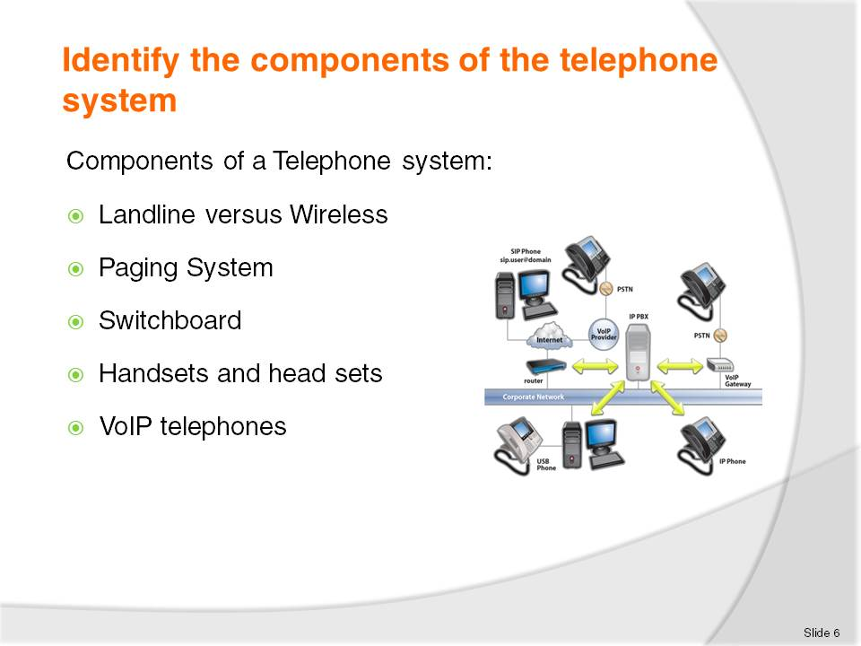
Slide No | Trainer Notes
A Landline telephone system is connected by solid wires or fibre optic cable, tangible and visible, from one location to another
Mobile or cellular phones make and receive calls using radio link or wireless connection
A paging system offers discrete and immediate communication for staff
Paging systems and mobile phones allow staff to work in operational areas and still be able to respond quickly to requests
A switchboard is a piece of equipment that enables a hotel or resort to connect all the telephone lines and extensions used
The handset is the part of the telephone which the user holds to their ear. Handsets are often referred to as receivers
Headsets fit over the head and enable hands free action which permits the operator to take notes or operate a computer while taking a telephone call
VoIP telephones use the internet to link and are rapidly increasing in usage, overtaking the traditional telephone network. The VoIP system enables notification of calls via email or text.

Slide
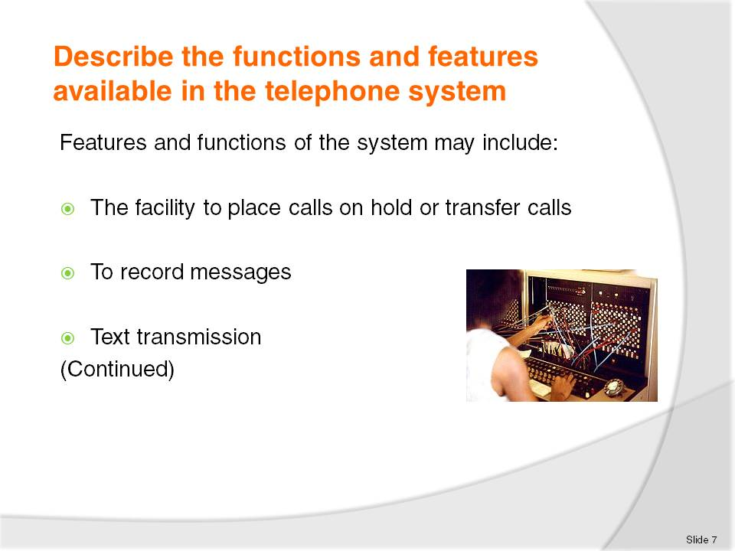
Slide No | Trainer Notes
The telephone system has a number of features and functions such as:
The facility to place calls on hold or transfer calls
To record messages electronically or use voicemail
Message or text transmission.
How would these features be used in practice to improve communication?

Slide
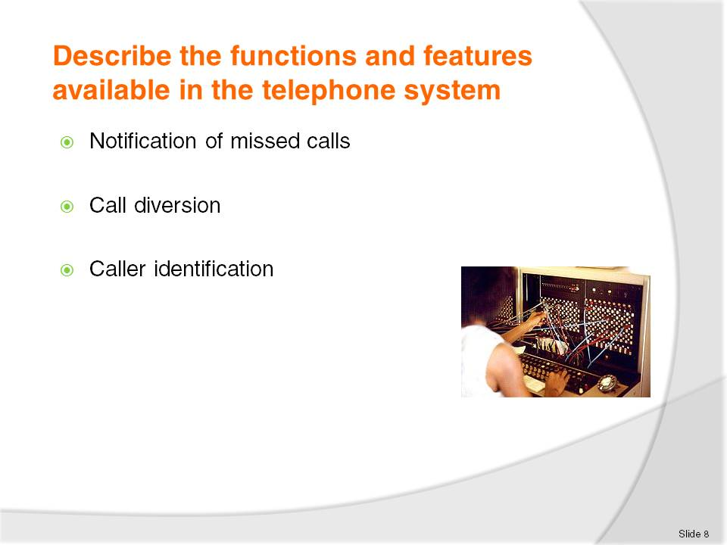
Slide No | Trainer Notes
The telephone system has a number of features and functions such as:
Notification of missed calls or busy numbers not answered
Call diversion and call blocking
Caller identification
How would these features be used in practice to improve communication?

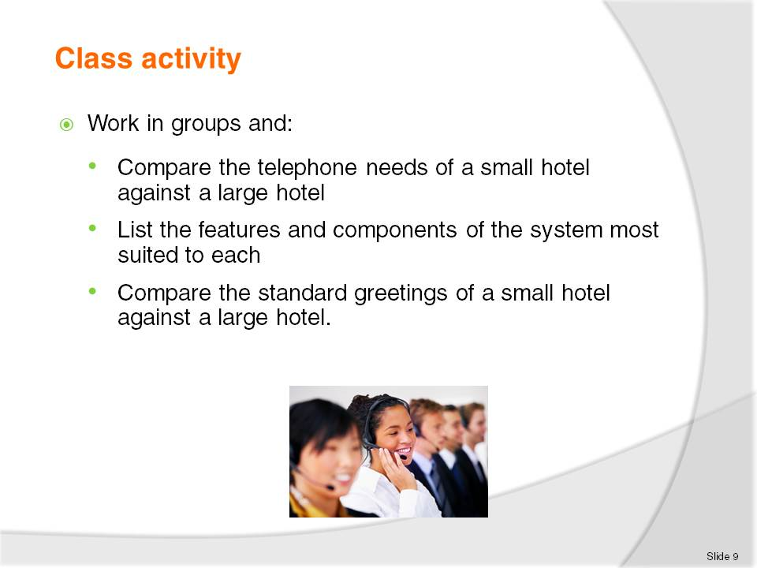
Slide No | Trainer Notes
Switchboard
Multiple extensions
Multiple lines
Computer interface
Monitor all incoming and outgoing calls
Timed calls
Fax & Internet access (in-room)
Email access (in-room)
Single telephone line
Fax access (Venue use only. May be separate number to telephone)
Telephone
Email access.

Slide
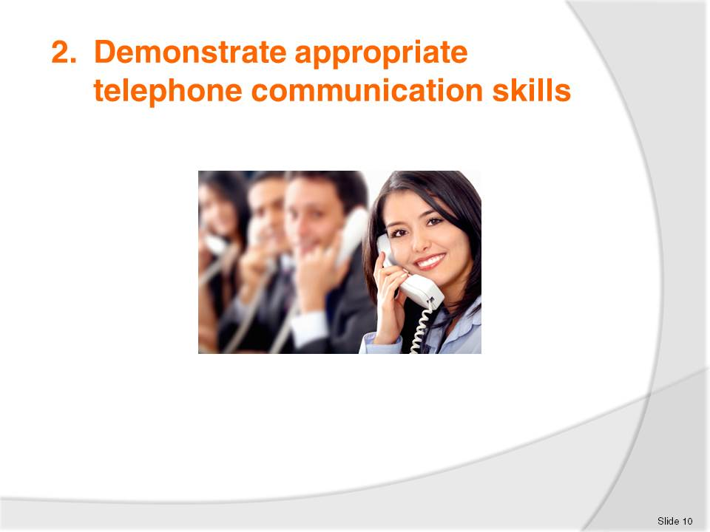
Slide No | Trainer Notes
 | Explain to trainees that this section will discuss issues such as privacy concerns, dealing with threatening calls, security issues and appropriate telephone greetings.

Slide
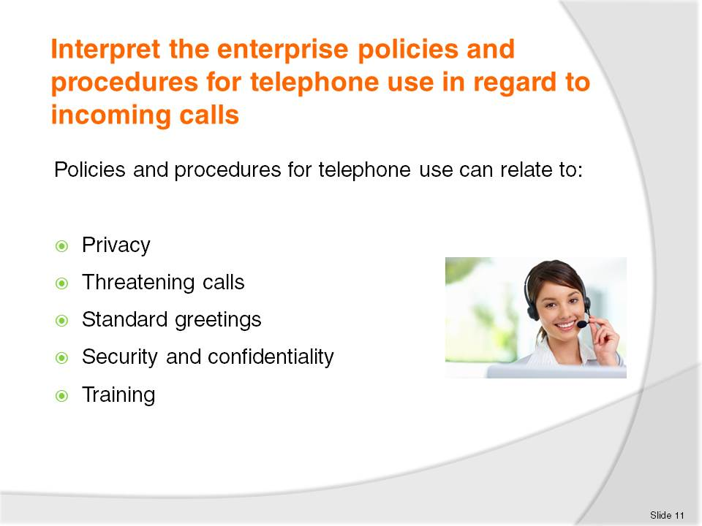
Slide No | Trainer Notes
The use of the telephone is one of the most vital business tools in use today
More business is won or lost on the phone than by any other means
Every staff member should undergo formal training in correct telephone procedures.
Privacy
A hotel or resort will have a policy to protect the privacy and confidentiality of its guests. Guests’ messages and phone records are protected against fraudulent actions.
Threatening calls
Response to threatening or suspicious calls requires the receiver to remain calm, the call should be taken seriously and the receiver should not hang up.
Greetings
Standard greetings are established to maintain image or service quality.
Staff should answer calls courteously and identify the time of day, and pronounce words clearly, slowly, and with adequate volume.
Security
Many hotels or resorts have created a “Privacy policy statement” relating to how and what they do with the personal information collected from guests.
Staff can often be tempted to pass on information about celebrities or prominent people to newspapers and magazines when these guests are staying at their hotel.
Training
Telephone system training is required to maintain the standards of the hotel or resort.
All systems require upgrading and even replacing and this will mean upgrade training for the staff.

Slide
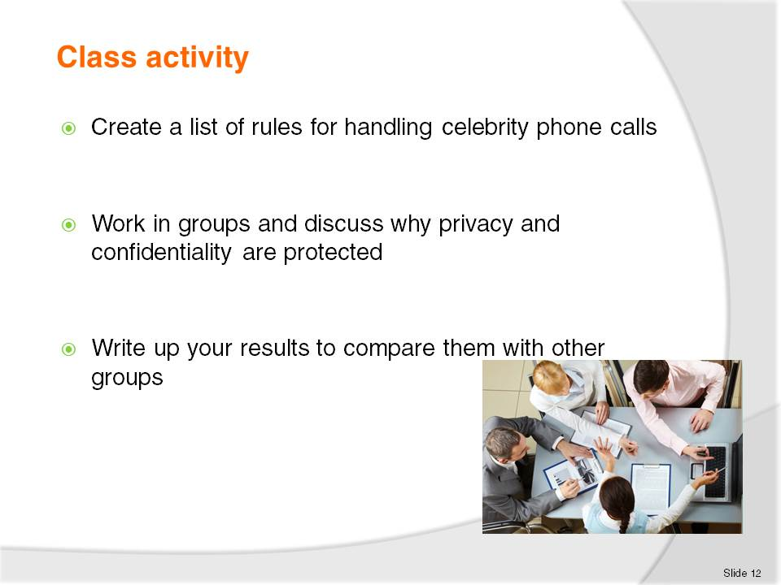
Slide No | Trainer Notes
Class discussion
If any of the class has worked or is currently working in a hotel they should tell the rest of the class some of the different ways celebrities are treated compared to ‘normal’ guests. What things are most important to celebrities? for example, privacy, security. The class should work in small groups and, once they have composed their lists, share them with the rest of the class.

Slide
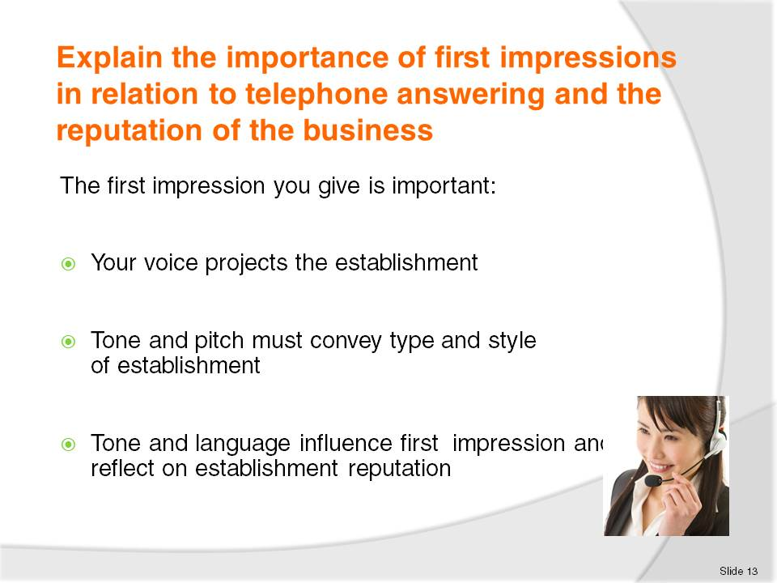
Slide No | Trainer Notes
The voice that answers the telephone projects the image of the establishment and the tone and pitch convey the type and style of establishment. Many establishments nominate a ‘script’ to follow so all staff who use the telephone system offer the same standard greeting and project the image of the establishment. The first impression a guest is given is lasting, and will be difficult to alter if it’s an unfavourable one. The tone and language of the greeting will also influence the all important first impression and reflect on the establishments’ reputation.
In pairs trainees should write what they think would be a good standard greeting for a 4 or 5 star hotel. Try reading it out loud using appropriate tone and pitch.

Slide
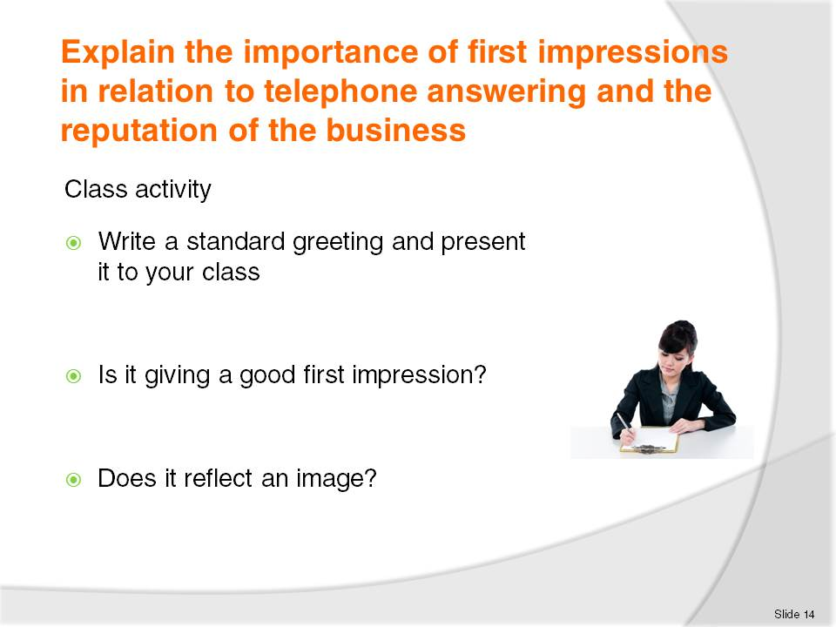
Slide No | Trainer Notes
 | In pairs trainees should write what they think would be a good standard greeting for a 4 or 5 star hotel. Try reading it out loud using appropriate tone and pitch.

Slide
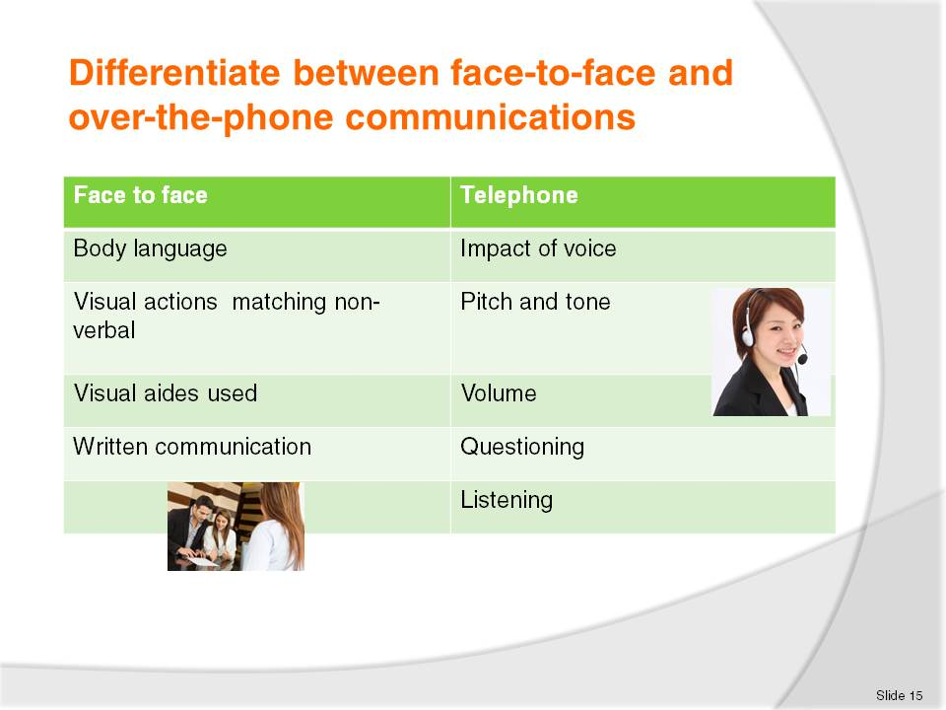
Slide No | Trainer Notes
Over the phone staff need to communicate the major part of any information with voice only. Therefore how and what is said is suddenly that much more important.
There is a need to think about voice tone, pace and volume, to project a professional image.
On top of that things that would normally be shown visually, like friendliness or enthusiasm, also need to be communicated through the voice.
During face to face conversation, people can not only hear responses from others, but also see their expressions and body language and interpret how they are feeling. Non-verbal responses can indicate that staff need to supply more information to clarify issues.
Class activity
Students should listen to each other repeating the standard greeting and comment on the sound of the voice.

Slide
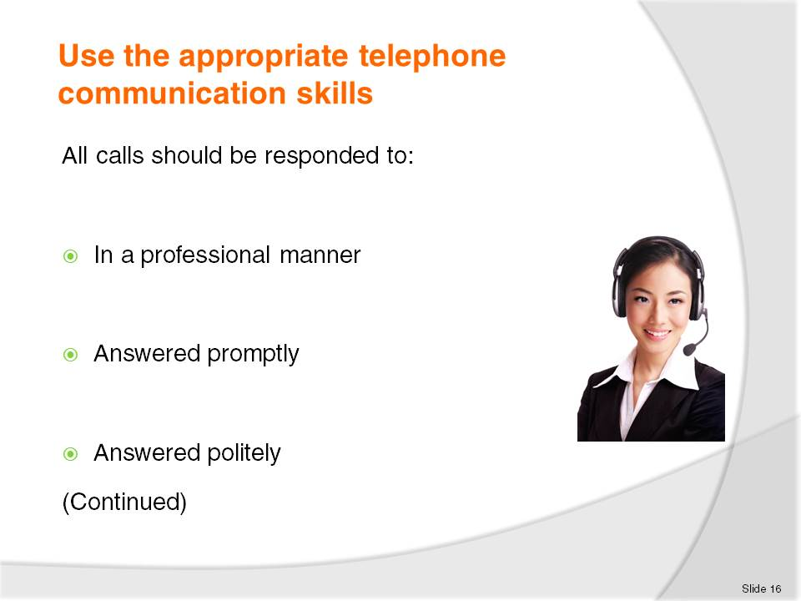
Slide No | Trainer Notes
Telephone communication requires certain skills including the appropriate attitude, energy level, voice tone and volume
The ability to speak clearly and distinctly with no jargon and an ability to listen attentively is also required.

Slide
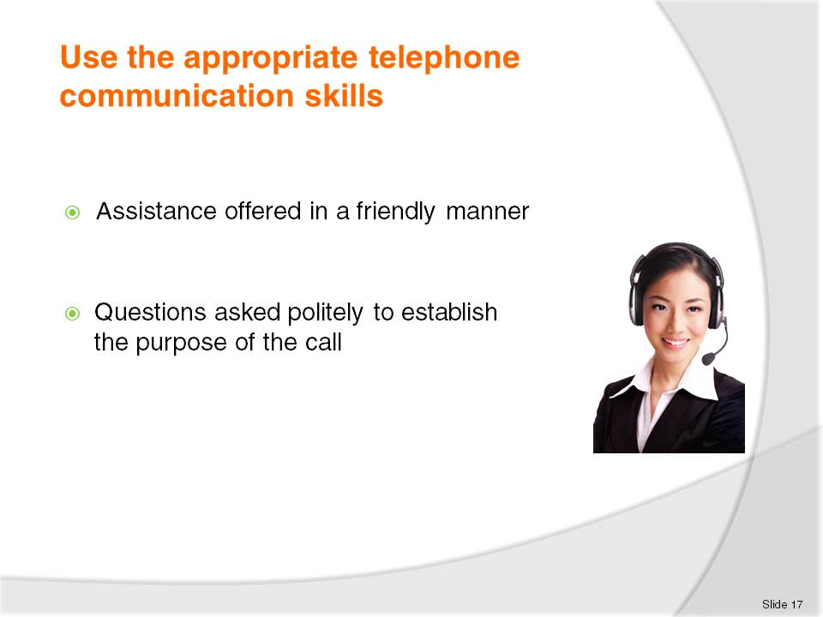
Slide No | Trainer Notes
Telephone communication requires certain skills including the appropriate attitude, energy level, voice tone and volume
The ability to speak clearly and distinctly with no jargon and an ability to listen attentively is also required.

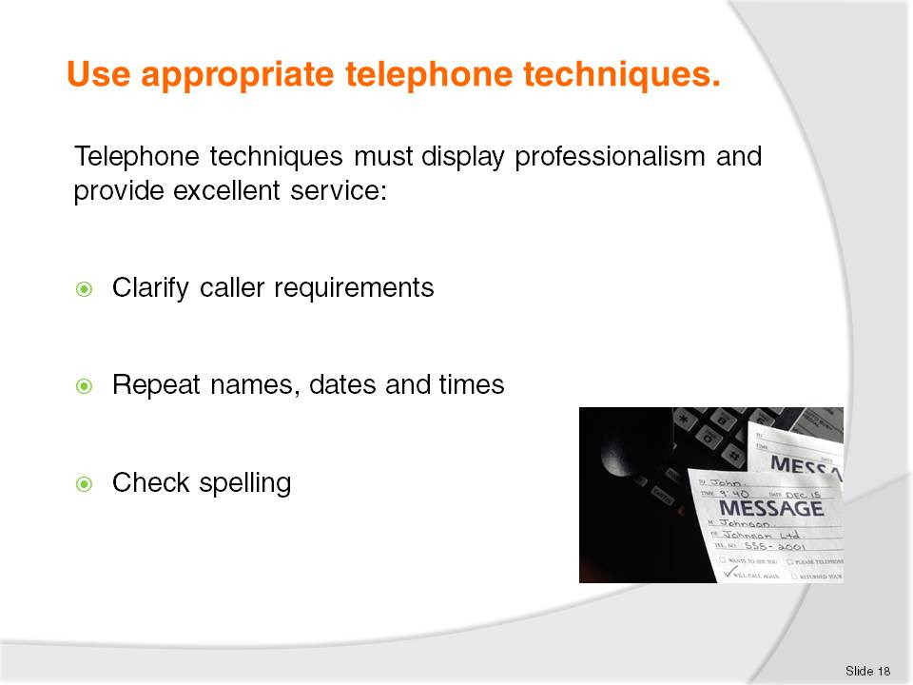
Slide No | Trainer Notes
Efficient and effective use of the telephone requires skill in use and knowledge of the telephone system and the procedures and policies.
All staff that use the telephone need to use appropriate telephone techniques.
Well-developed telephone techniques will display an impression of professionalism and provide excellent service.
Clarify caller requirements
Use your questioning and listening skills to clarify what the caller has requested.
Repeat names, dates and times
Whenever guests give you details like their name make sure you spell it correctly. If you are not sure about the spelling then ask the guest to spell it. Read the letters back to the guest for clarification. Using the phonetic alphabet will help with an misunderstanding of letters being heard over the phone.

Slide
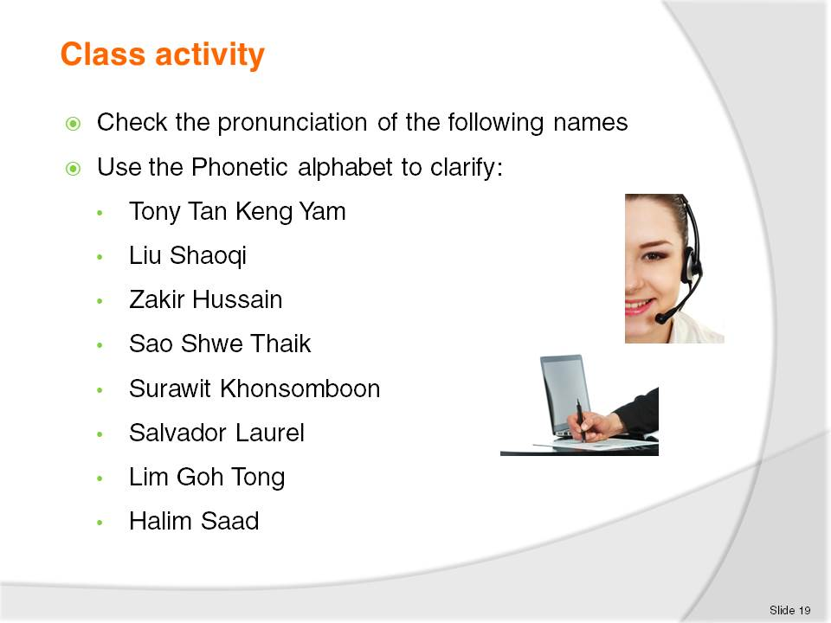
Slide No | Trainer Notes
Clarify caller requirements
The trainee/students do the conversation in pairs and the student who will be the operator needs to rewrite the guest’s name.

Slide
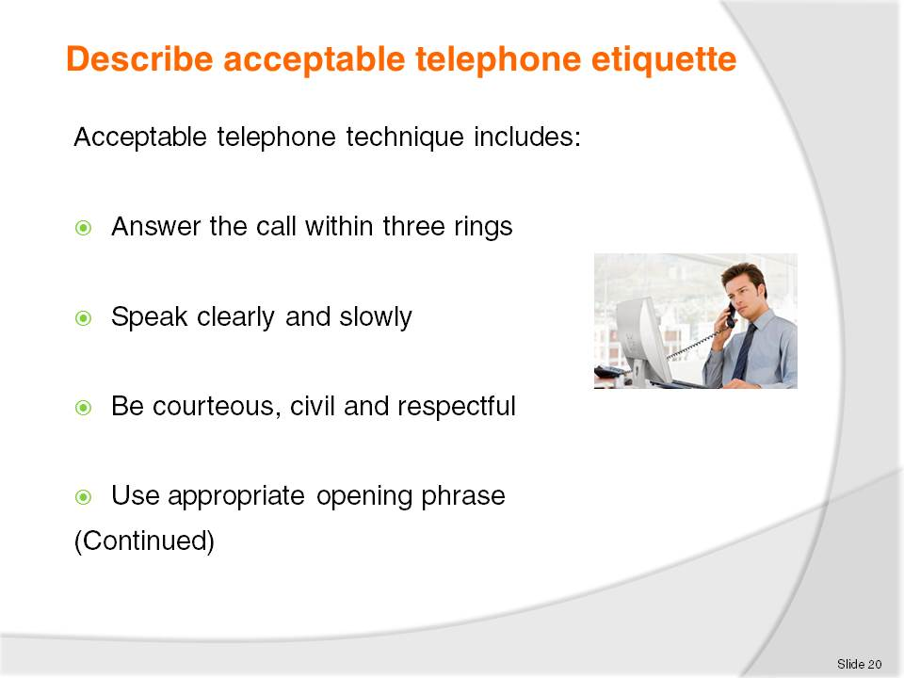
Slide No | Trainer Notes
Telephone Etiquette
Answer the call within three rings
Always speak clearly and slowly with courtesy, civility and respect
Avoid extreme volumes
Avoid jargon or hotel terminology
Speak with a smile on your face
Use an appropriate opening phrase and listen to the response. Reduction of background noise can make hearing more efficient.

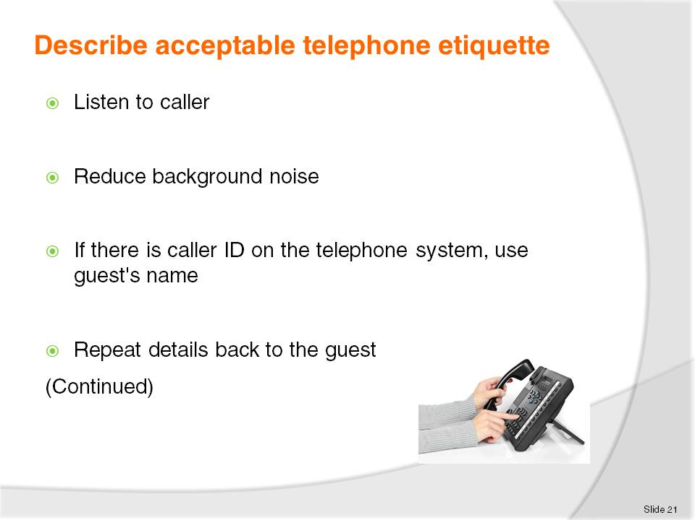
Slide No | Trainer Notes
 | Trainer continues to discuss telephone etiquette with trainees inviting comments and stories from personal experience.

Slide
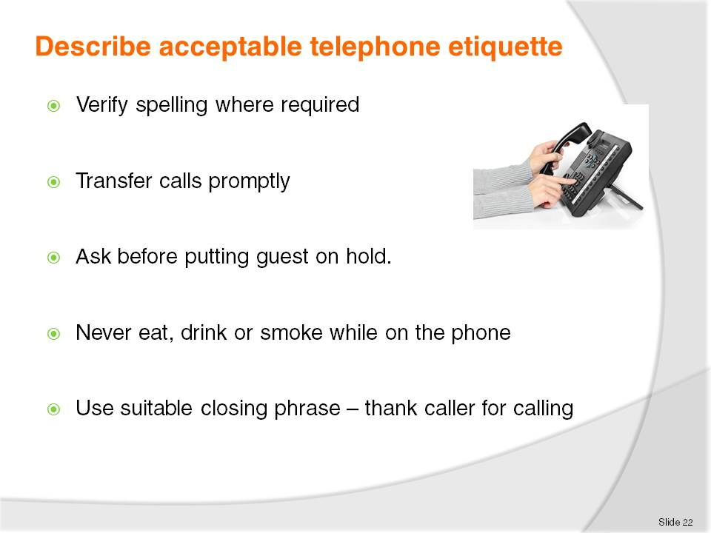
Slide No | Trainer Notes
 | Trainer continues to discuss telephone etiquette with trainees inviting comments and stories from personal experience.

Slide
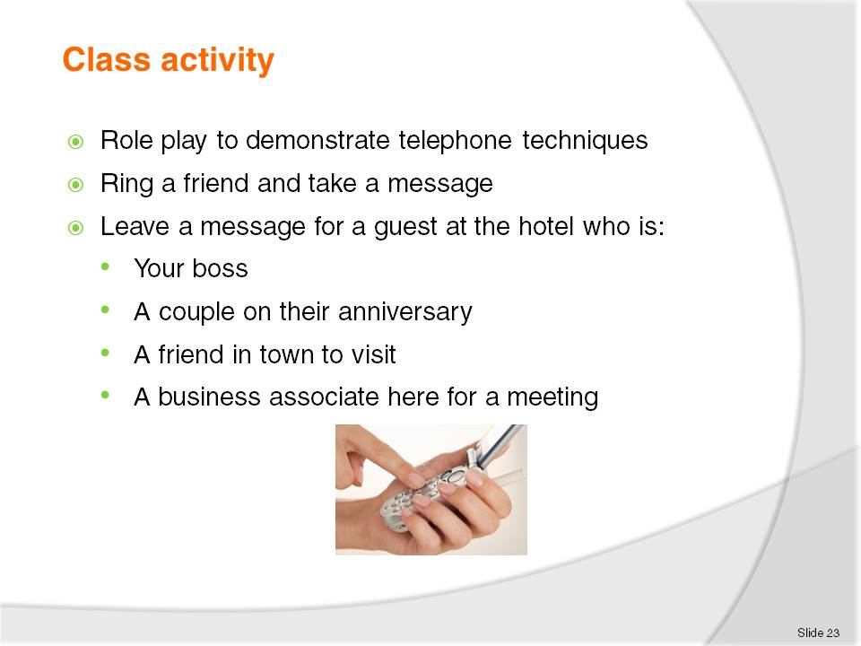
Slide No | Trainer Notes
 | Role play can happen in pairs and later be shared with a larger group.

Slide
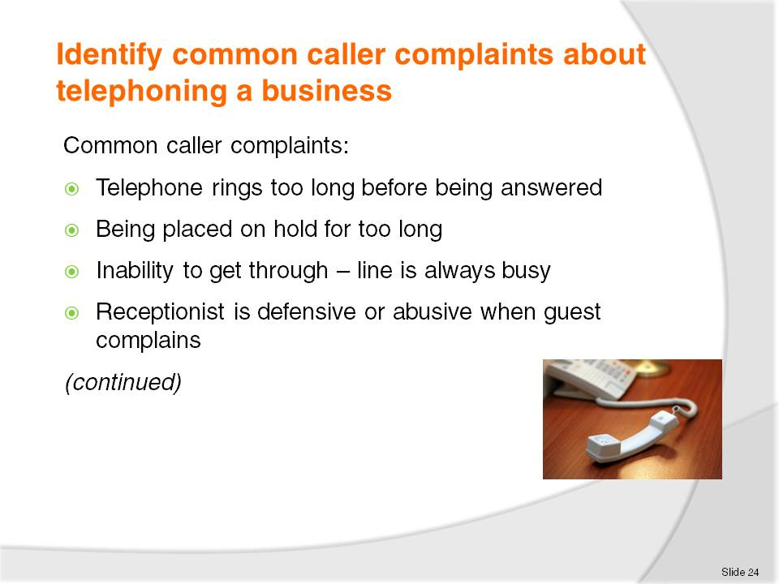
Slide No | Trainer Notes
Common caller complaints
The telephone rings too long before being answered. If the guest is waiting to have a call answered they can become frustrated and angry. Some telephones have capacity to record how long a phone rings before it's attended to. A guest speaking face to face with staff will find it distracting if a phone rings and rings without being answered
Being placed on hold for too long, Guests should always be asked if they want to be on hold or for a message to be taken. If a guest is on hold then staff should check back frequently
Inability to get through, such as the line or number is always busy. Again if the guest is waiting to have a call answered they can become frustrated and angry. Some venues have electronic messaging or voicemail to avoid this
If a guest has complained and the receptionist becomes defensive or abusive. The guest or caller may ask for the receptionist’s name so the guest can take their complaint further.

Slide
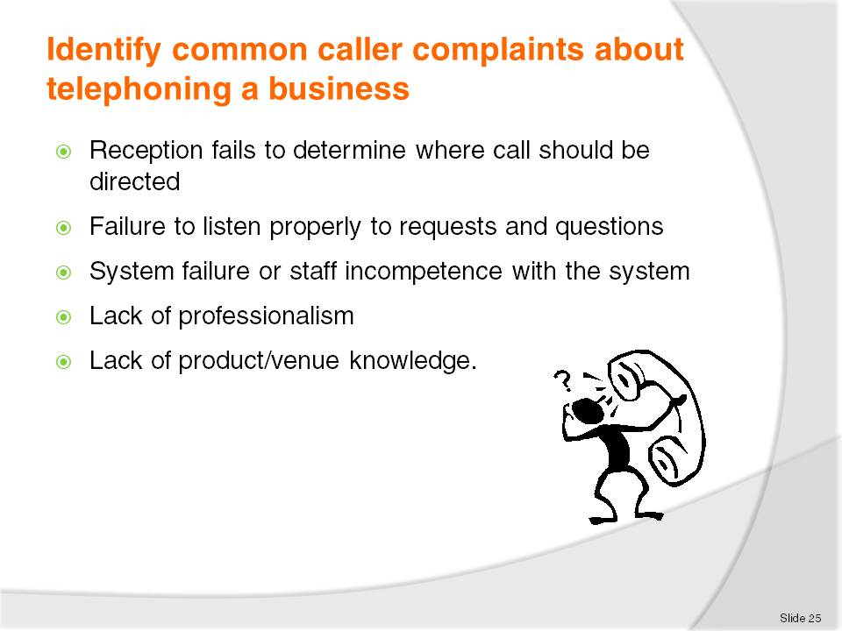
Slide No | Trainer Notes
Difficulty can arise if reception or the switchboard fails to determine where the call should be directed. This could mean there has been a failure to update contact information
One of the important points of communication is to listen. Failure to listen to guests’ requests and questions can lead to misunderstanding and disgruntled guests
All systems can experience system failure. Often the failure is outside the control of management. Occasionally incompetence with the system; for example, the caller is disconnected when being transferred is the cause of guest dissatisfaction
Lack of professionalism, including failure to place call on hold before talking to colleagues, giving an inappropriate greeting, lack of knowledge about the establishment and its staff and the use of an improper tone of voice by receptionist are all situations which can be cause for caller complaint.

Slide
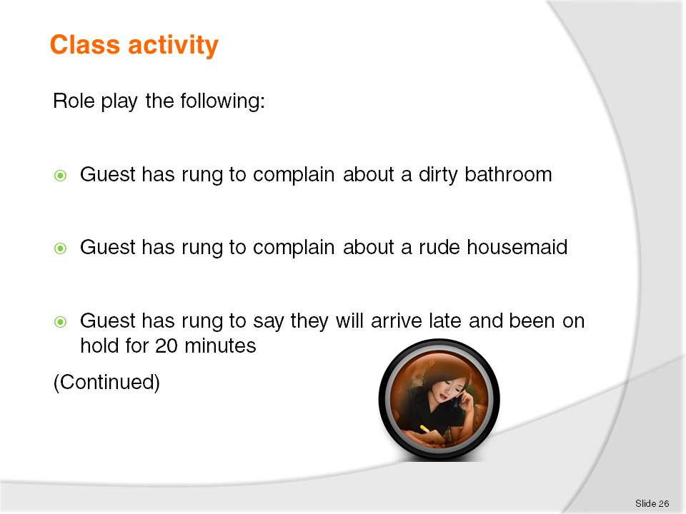
Slide No | Trainer Notes
 | This activity should be done in pairs.

Slide
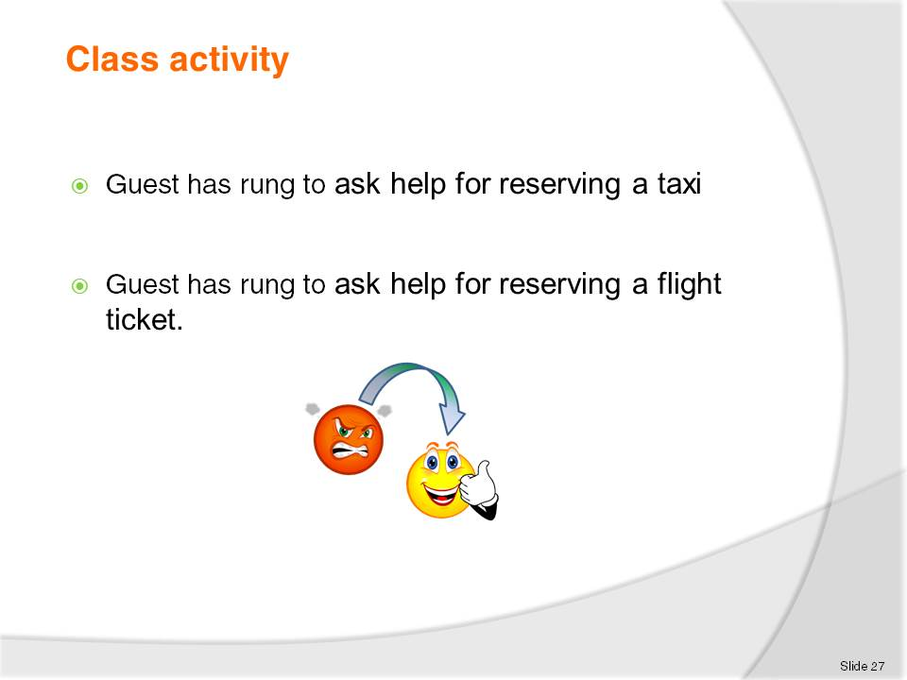
Slide No | Trainer Notes
 | This activity should be done in pairs.

Slide

Slide No | Trainer Notes
 | Trainer to discuss content of this Element with trainees.

Slide
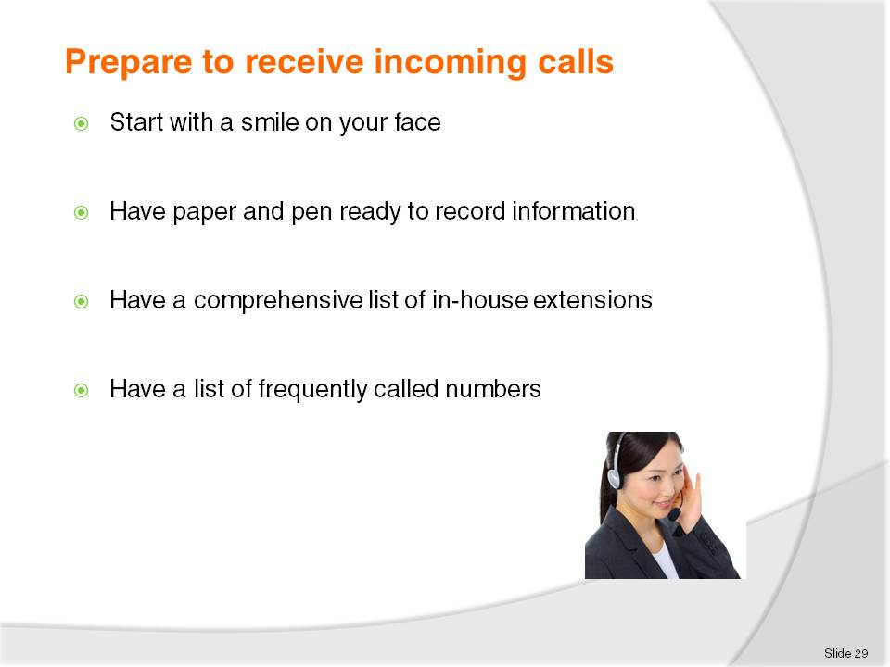
Slide No | Trainer Notes
Reception or telephone staff should be doing all the necessary things in order to efficiently and confidently receive and make telephone calls:
Smile – this will reflect in your voice when you are talking, improving the tone and pitch
Paper and pen ready to record information
A list of in-house extensions by the phone, this may be electronic or written, or may be the in-house guest report as produced by the night audit
Have a list of frequently called numbers such as taxis, theatres, restaurants, tourist tour operators or other external services. There should also be a list of emergency numbers.
When operating the telephone system staff must ensure there are no outside distractions.

Slide
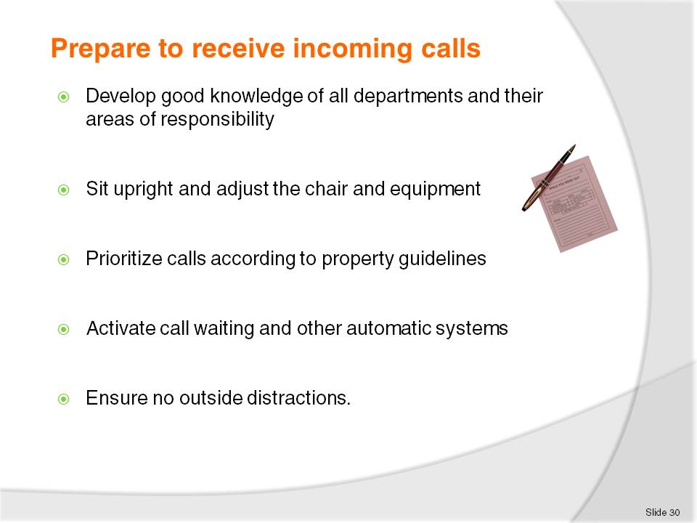
Slide No | Trainer Notes
Reception or telephone staff should be doing all the necessary things in order to efficiently and confidently receive and make telephone calls:
smile – this will reflect in your voice when you are talking, improving the tone and pitch
paper and pen ready to record information
a list of in-house extensions by the phone, this may be electronic or written, or may be the in-house guest report as produced by the night audit
have a list of frequently called numbers such as taxis, theatres, restaurants, tourist tour operators or other external services. There should also be a list of emergency numbers
know where and how to direct each enquiry. A good knowledge of all departments and their areas of responsibility will ensure prompt response to all enquiries
sit upright and adjust the chair and equipment to best suit the person's stature
knowledge of all operator connected calls, and directory assistance procedures
prioritize calls according to property guidelines

activate call waiting and other automatic systems.
  - message waiting system
  - the wakeup call system
  - activate the voice mail system.
When operating the telephone system staff must ensure there are no outside distractions.

Slide
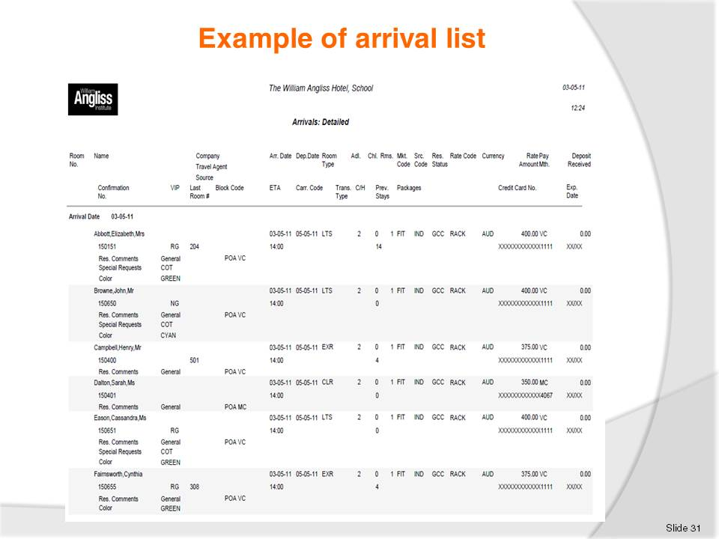
Slide No | Trainer Notes
 | Discuss the above example of an arrivals list – Opera Software.

Slide
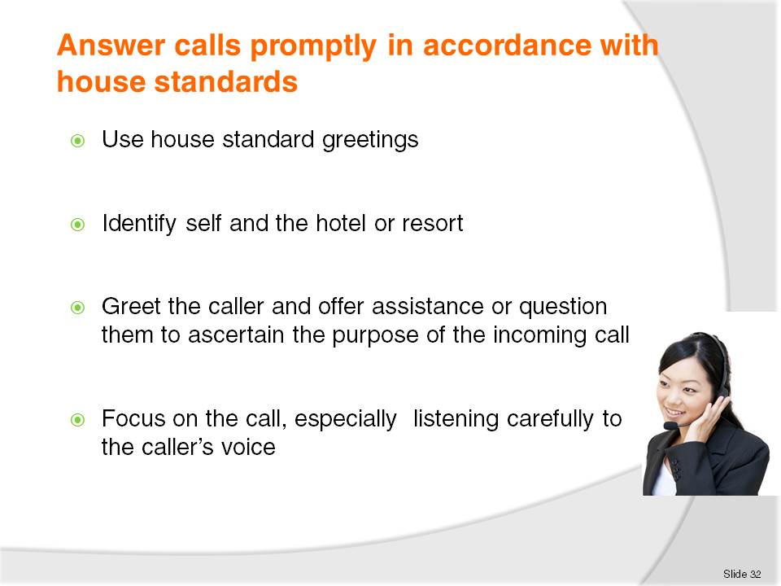
Slide No | Trainer Notes
All staff who use the telephone to accept incoming calls should maintain the same standard etiquette and skills.
When answering call staff should ensure all calls:
Are answered before house ring limit is reached, usually by the third ring
Use an enterprise standard greeting is a statement of who you are and what your establishment’s values are
Identifying self or position and the hotel or resort, greet the caller and offer assistance or question them to ascertain the purpose of the incoming call
Focusing and concentrating on the call, especially listening carefully to the callers voice.

Slide
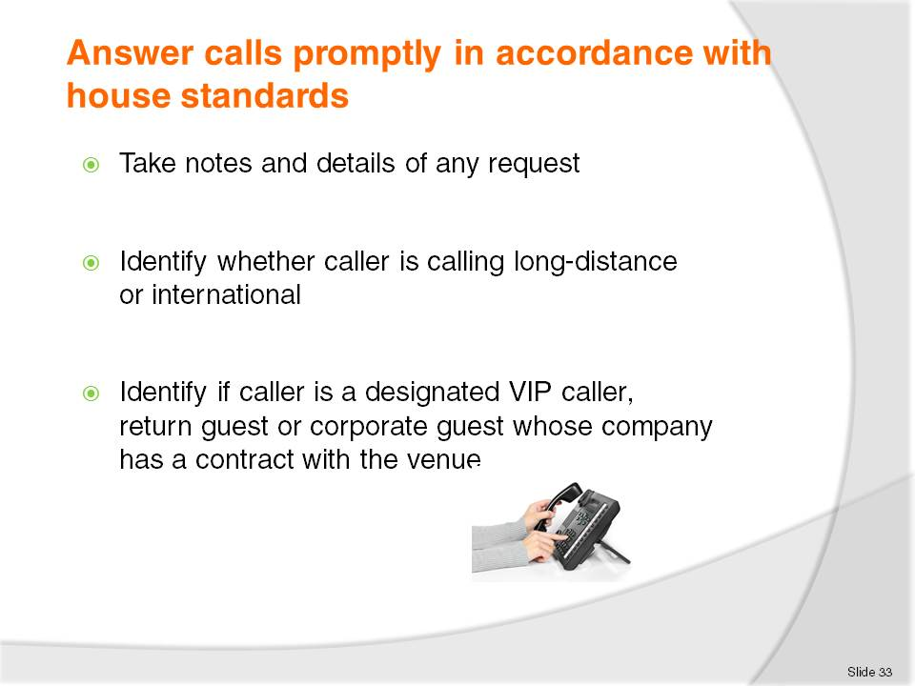
Slide No | Trainer Notes
All staff who use the telephone to accept incoming calls should maintain the same standard etiquette and skills.
When answering call staff should ensure all calls:
Are answered before house ring limit is reached, usually by the third ring
Use an enterprise standard greeting is a statement of who you are and what your establishment’s values are
Identifying self or position and the hotel or resort, greet the caller and offer assistance or question them to ascertain the purpose of the incoming call
Focusing and concentrating on the call, especially listening carefully to the callers voice
Taking notes and details of any request
Identifying whether caller is calling long-distance or internationally
Identifying if caller is a designated VIP caller, a return guest or a corporate guest whose company has a contract with the hotel or resort.

Slide
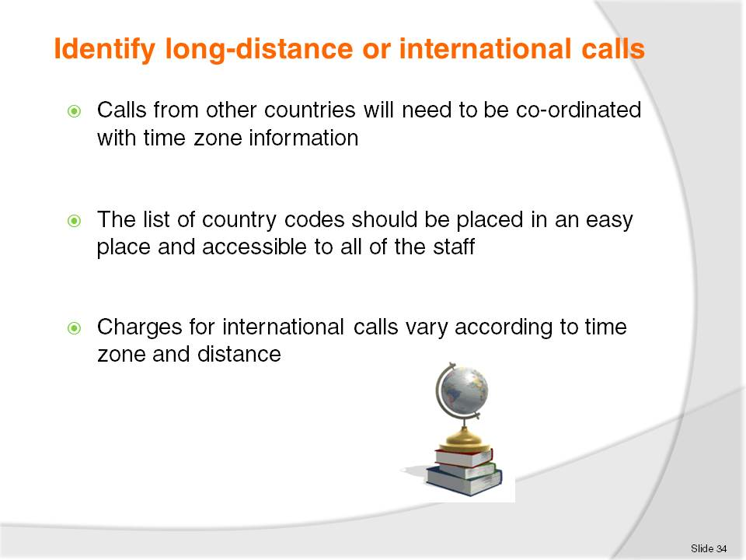
Slide No | Trainer Notes
Calls from other countries will need to be co-ordinated with time zone information.
Charges for international calls vary according to time zone and distance.

Slide
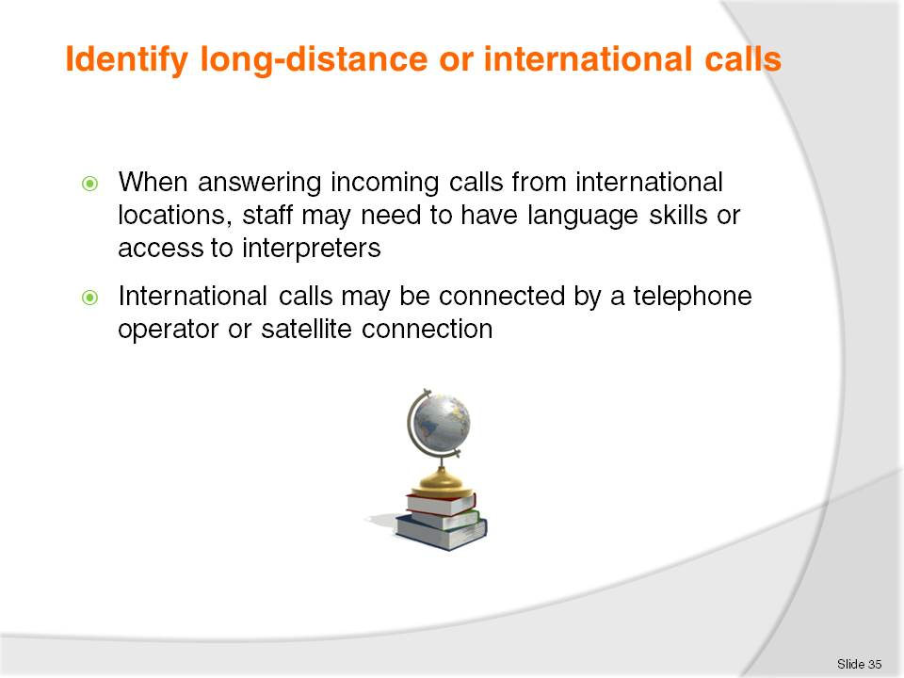
Slide No | Trainer Notes
When answering incoming calls from international locations, you need language skills or access to interpreters or software that would perform translation.
International connected by a telephone operator or satellite connection; fees will vary according to the country and duration of the call. A satellite call is more expensive than wireless connection.

Slide
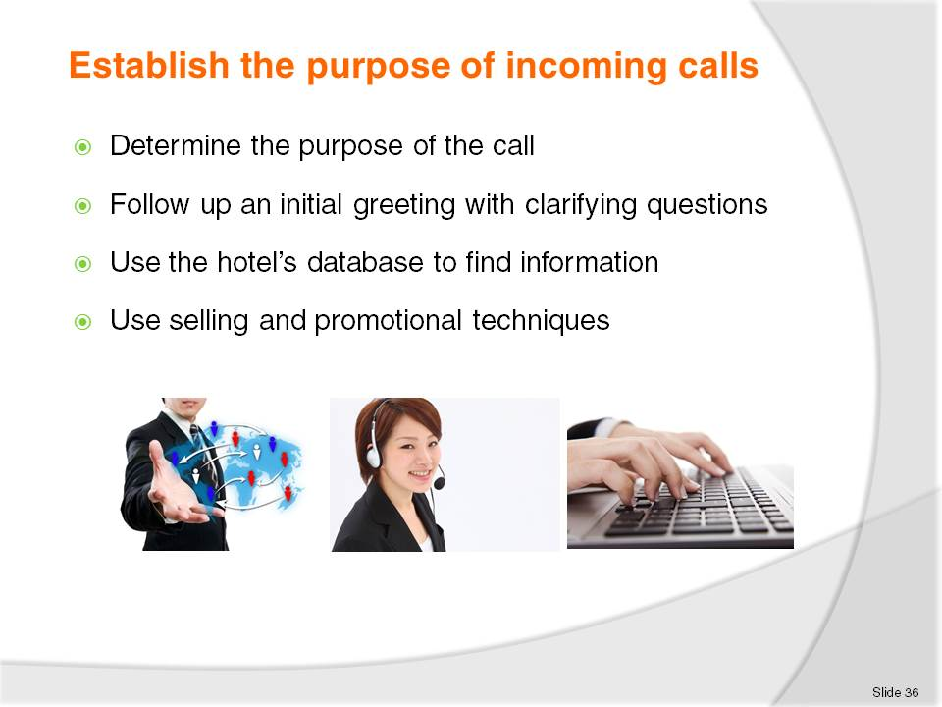
Slide No | Trainer Notes
When receiving incoming calls it’s important to determine the purpose of the call so it can directed to the appropriate staff or department In a large hotel or resort
The telephone operator may answer calls on behalf of several different departments and then transmit the information to appropriate staff by pager or text.

Slide
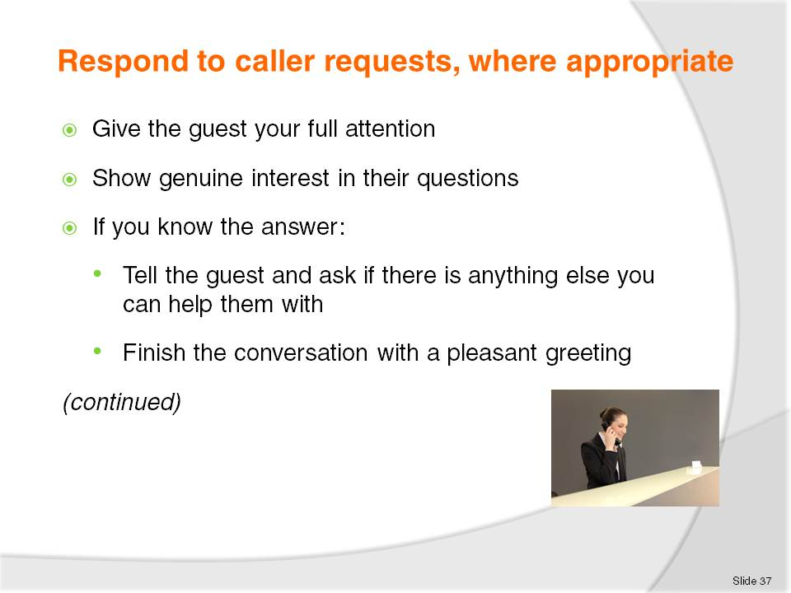
Slide No | Trainer Notes
Respond to guest requests:
React promptly, give the guest your full attention and show genuine interest in their questions.
If you know the answer:
Tell the guest and ask if there is anything else you can help them with
Finish the conversation with a pleasant greeting, e.g. ‘I hope you enjoy your stay’.

Slide
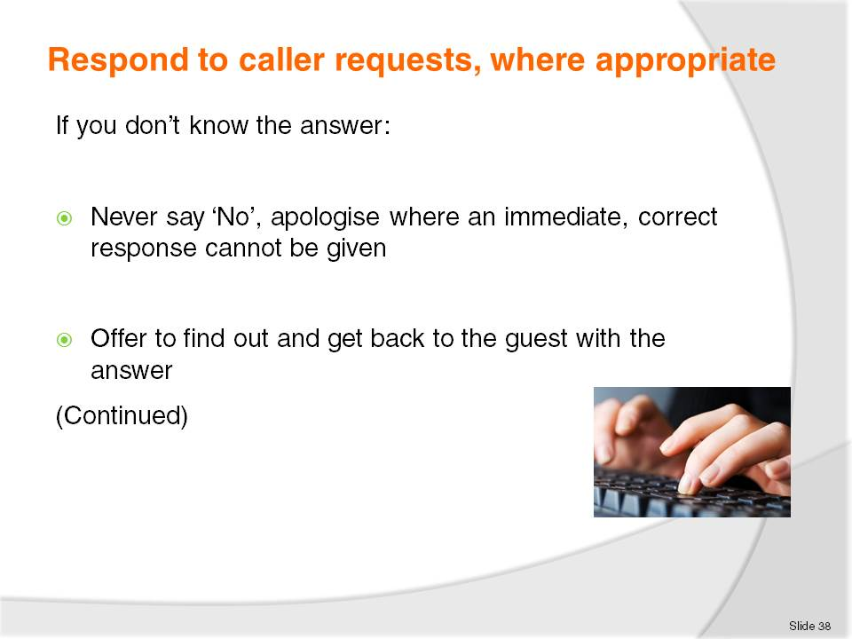
Slide No | Trainer Notes
If you don’t know the answer:
Never make it up or say, ‘ I don’t know’ or ‘That’s not my department’. You should apologise where an immediate, correct response cannot be given.
Offer to find out and get back to the guest with the answer. This may involve putting the guest on hold or taking details and returning the call.

Slide
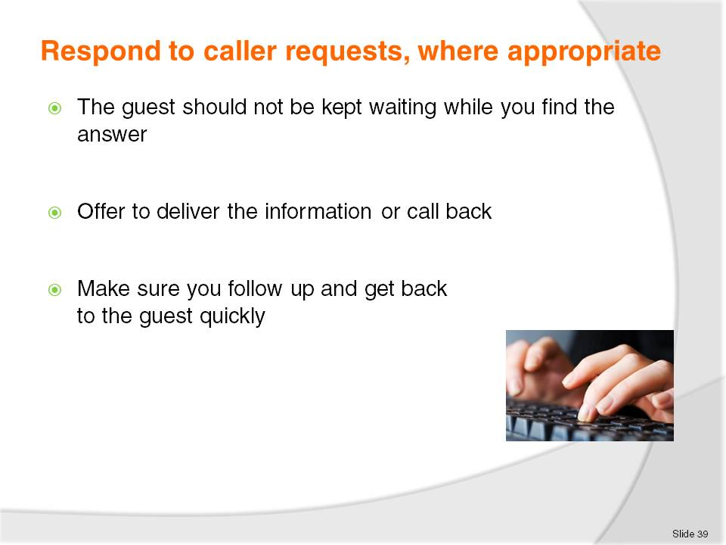
Slide No | Trainer Notes
Do not keep the guest waiting while you try to find the answer. Offer to deliver the information or call back or transfer the call to a guest services attendant or another department who can best answer the question
Make sure you follow up and get back to the guest quickly.

Slide
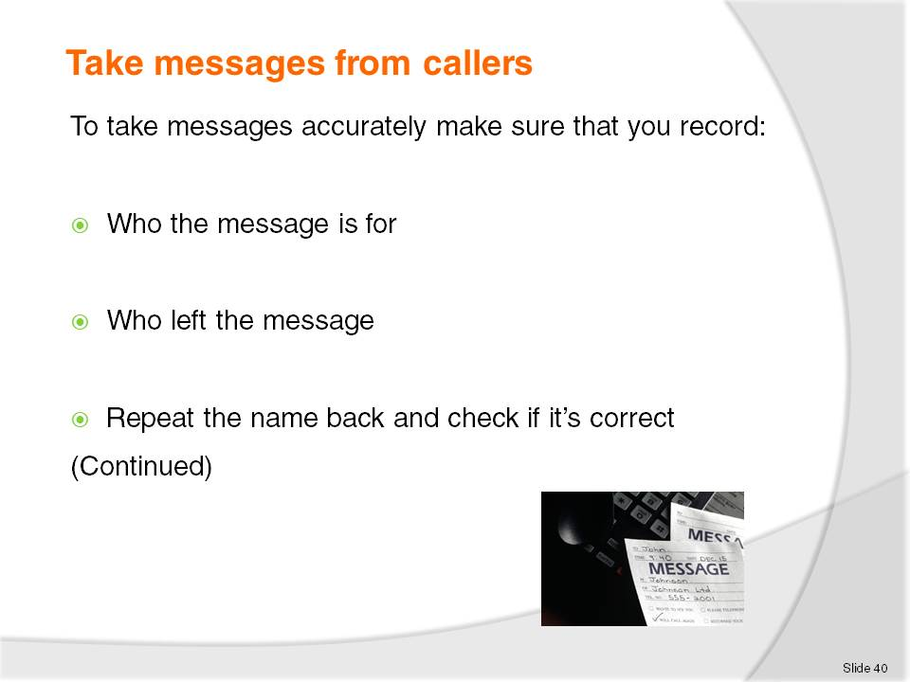
Slide No | Trainer Notes
To take messages accurately make sure that you record:
Who the message is for asking for the full name and remembering that you might have 10 guests with the name Ng or Lee staying in the hotel
Who left the message; repeat the name back and make sure that you have the correct spelling. Record any details of Company and the caller’s city, which is required to estimate time for the return call to occur
The number and any extension of the person leaving the message. Check and repeat this back to the caller so that you do not give your guest the wrong number.

Slide
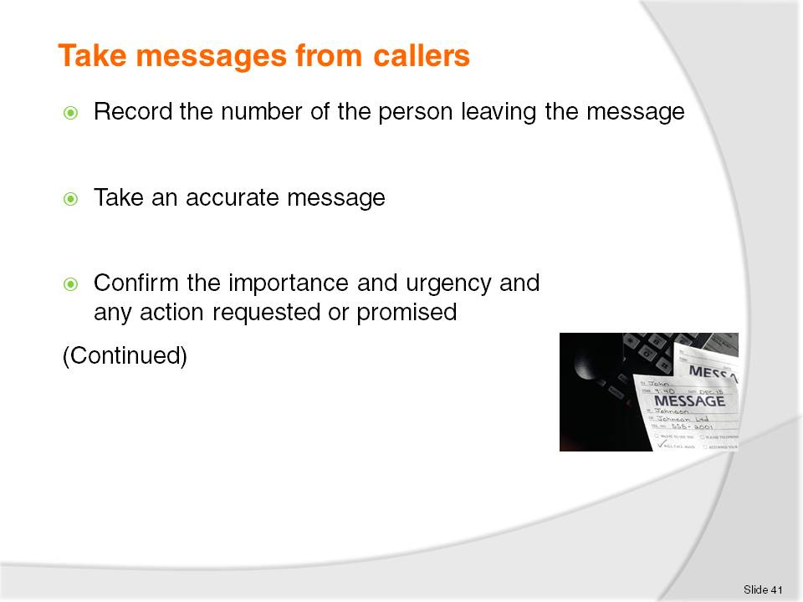
Slide No | Trainer Notes
The number and any extension of the person leaving the message. Check and repeat this back to the caller so that you do not give your guest the wrong number
An accurate message should be taken; repeat the message back to confirm this with the caller. Confirm the importance and urgency and any action requested or promised.

Slide
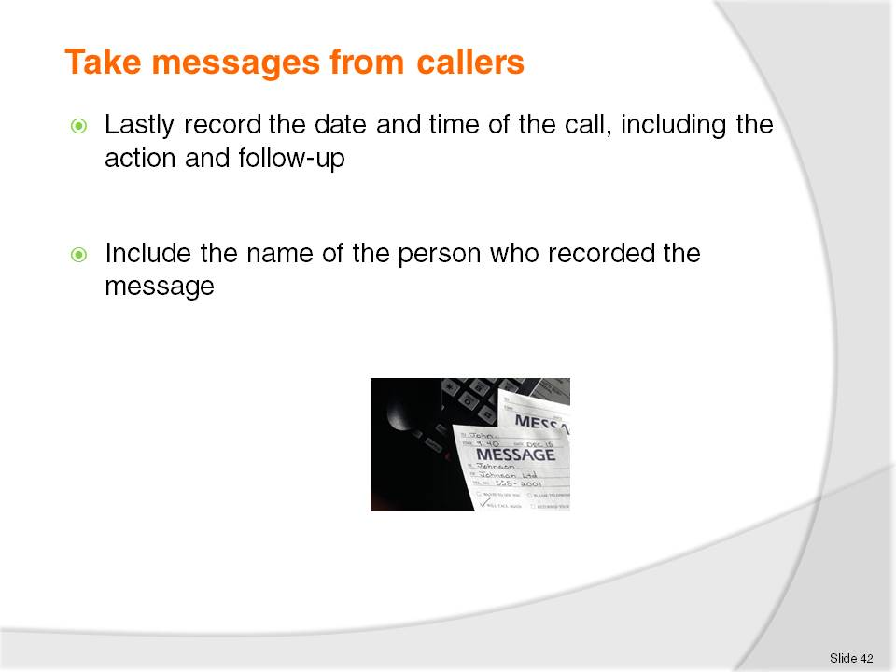
Slide No | Trainer Notes
 | Lastly record the date and time of the call, including the action and follow-up .Also include the name of the person who recorded the message. If the message has been entered into an electronic system or PMS, then it will automatically be dated, time stamped and carry the ID of the staff member who entered the data.

Slide
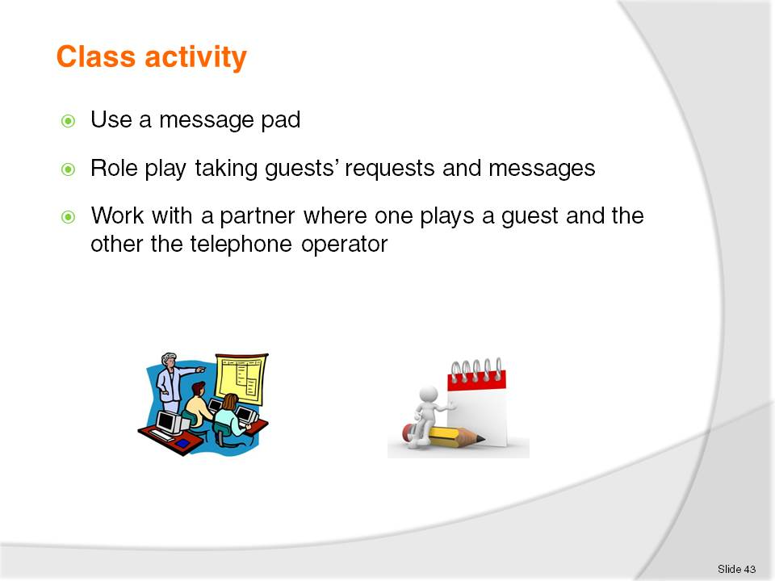
Slide No | Trainer Notes
 | This helps the students become familiar with the art of message taking.

Slide
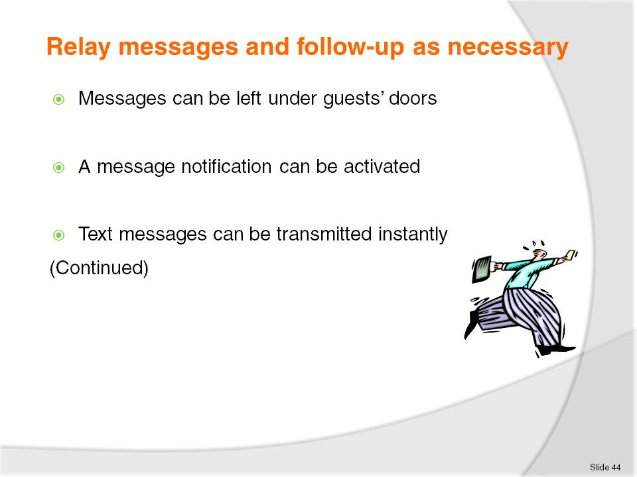
Slide No | Trainer Notes
All messages received and recorded need to be distributed to their recipients
In regards to distribution of messages it is essential that it is timely and accurately distribute.

Slide
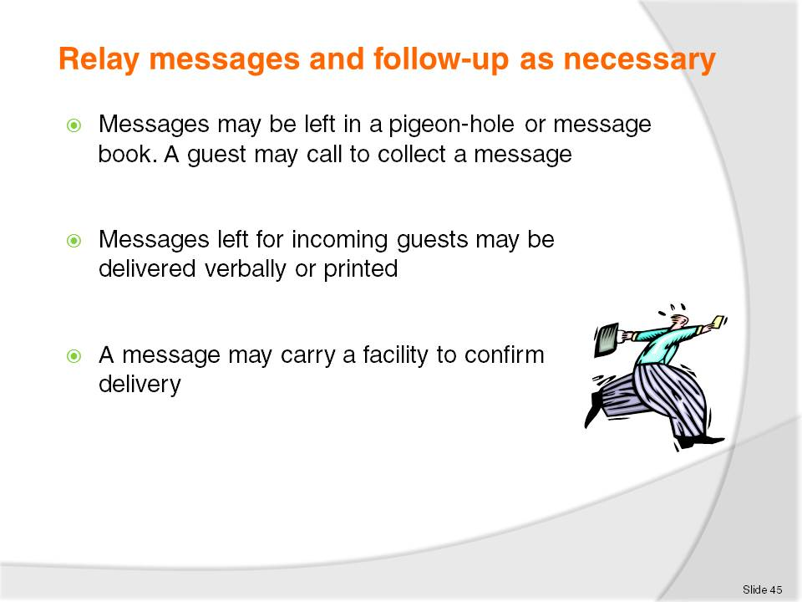
Slide No | Trainer Notes
Porter duties usually include taking messages, packages or mail for in-house guests in liaison with reception staff, receiving and distributing guest mail, messages, emails and faxes
A message may be left for an expected guest and notification can be attached electronically to the reservation information.

Slide
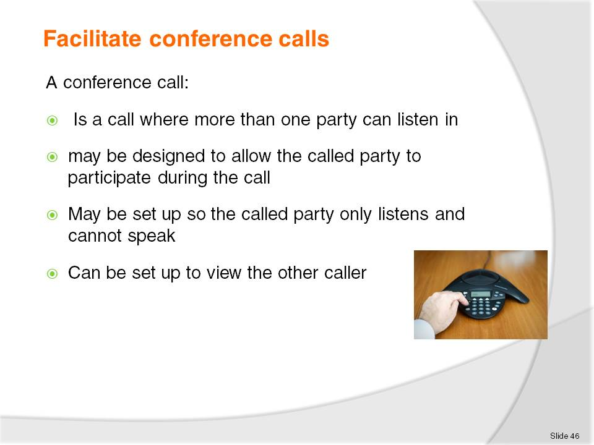
Slide No | Trainer Notes
 | A conference call is a telephone call in which the calling party wishes to have more than one called party listen in to the audio portion of the call. The conference calls may be designed to allow the called party to participate during the call, or the call may be set up so that the called party merely listens into the call and cannot speak. It can also be set up to view the other caller. This is sometimes called Teleconference.

Slide
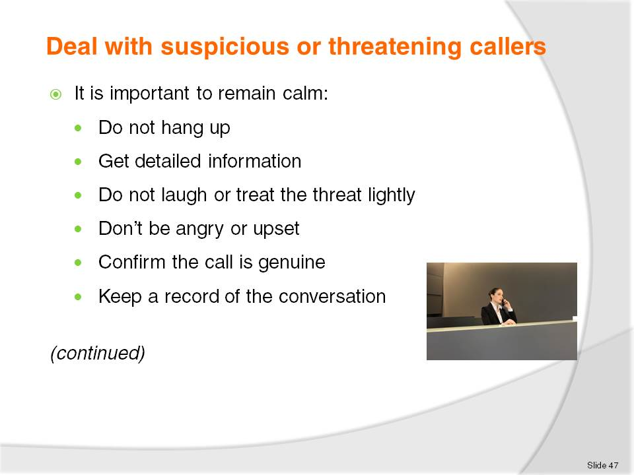
Slide No | Trainer Notes
Whatever the threat or suspicious behaviour there are certain steps to follow.
It is important to remain calm. Do not hang up as this can enable the authorities to trace the call. By capturing as much detail as possible about the call, caller and nature of the threat, the caller should be treated with respect and not abused. Staff should not laugh or treat the threat lightly. It’s important not to be angry or upset as this could cause the caller to become agitated and hang up or escalate the situation. But it is also important to confirm the call is genuine and not a prank or joke. Despite the cause or reason a record should be kept of the conversation.

Slide
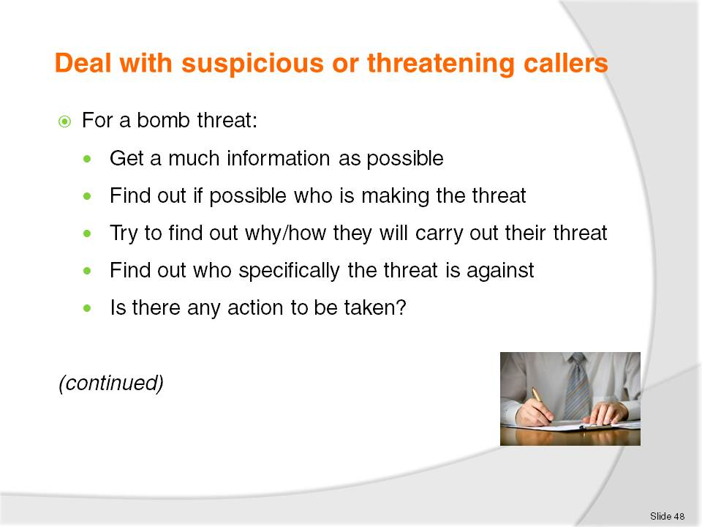
Slide No | Trainer Notes
 | If it’s a bomb threat then try to get as much information as possible, who the group or individuals are who are making the threat, why and how they will carry out their threats. There is a need to establish who specifically the threat is against and why or when it will occur. Is there any action the telephonist can take that will solve the problem or difficulty?

Slide
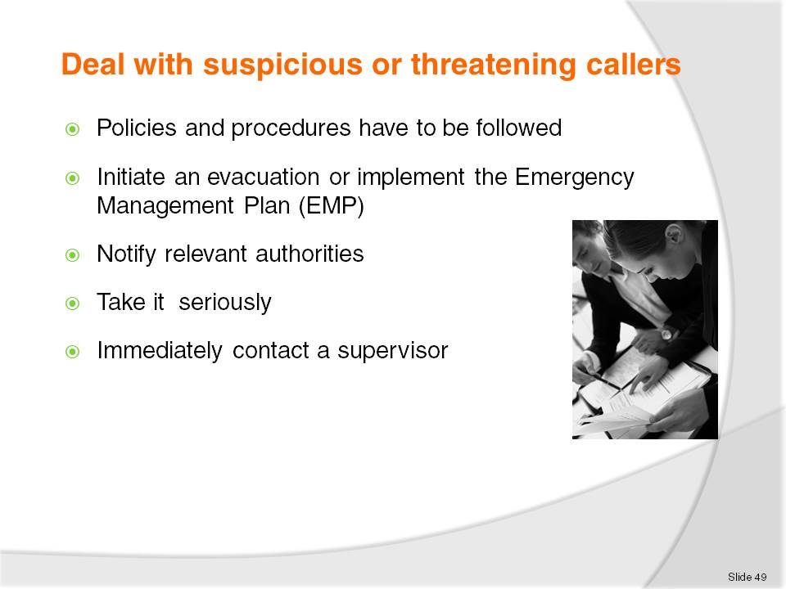
Slide No | Trainer Notes
The venue’s policies and procedures have to be followed and management and other staff notified of the situation. It may be that staff need to initiate an evacuation or implement the Emergency Management Plan (EMP) and also notify relevant authorities. If there is a serious threat management will call departments and room numbers to facilitate the warning of people in accordance with the Emergency Management Plan.
All threats and suspicious behaviour should be taken seriously and immediately contact a supervisor as to what is occurring.

Slide
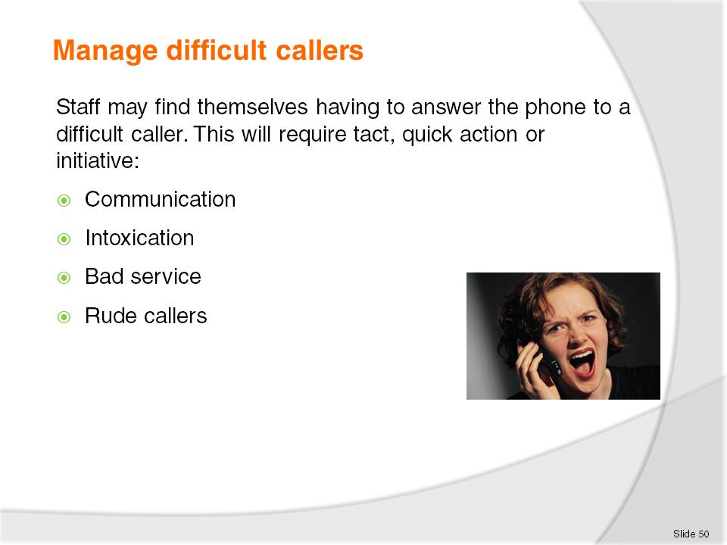
Slide No | Trainer Notes
When answering a difficult call the telephonist must first listen, then apologise.
Come to a conclusion explaining what action can be taken. Identify how the complaint will be dealt with and always follow up.
By capturing as much detail as possible about the caller the caller should still be treated with respect. But it is also important to confirm the call is genuine and not a prank or hoax. Despite the cause or reason a record should be kept of the conversation. A difficult guest may simply be misunderstood, but for those who are angry or upset and not responding positively, remember to be tactful, keep cool, sympathise and try to give assistance but always call or notify management.

Slide
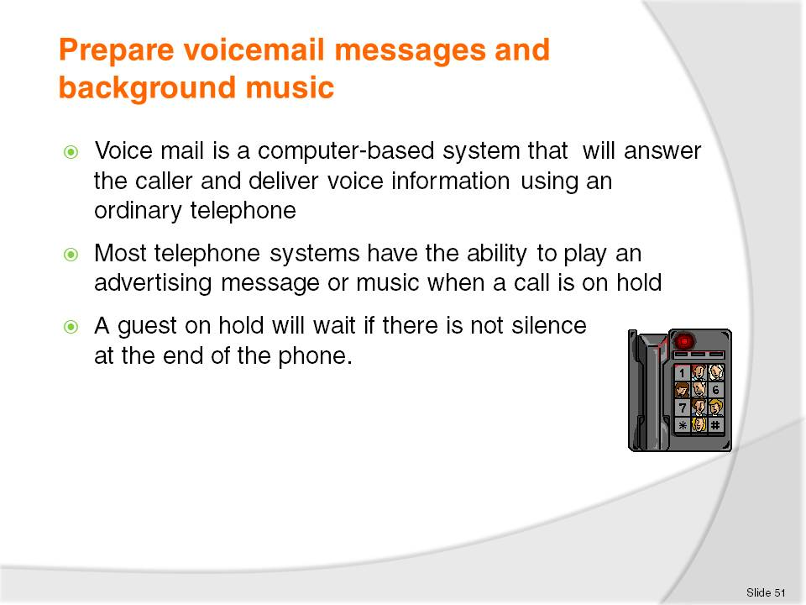
Slide No | Trainer Notes
Voice mail is a computer-based system that will answer the caller and deliver voice information about organisations, products and services, using an ordinary telephone. The term is also used more broadly to denote any system of conveying a stored voice messages
Voicemail systems are designed to convey a caller's recorded audio message to a recipient
Most telephone systems have the ability to play an advertising message or music when a call is placed on hold or before it answers
Calls are placed on hold because there is a bank up of calls and the operator is busy
Sometimes calls are put on hold manually. For instance, when you need to get some information for the guest you will inform them that they are going to be put on hold while you collect this information or speak to a supervisor. In this circumstance music or promotional messages can be used rather than the caller listening to nothing.

Slide
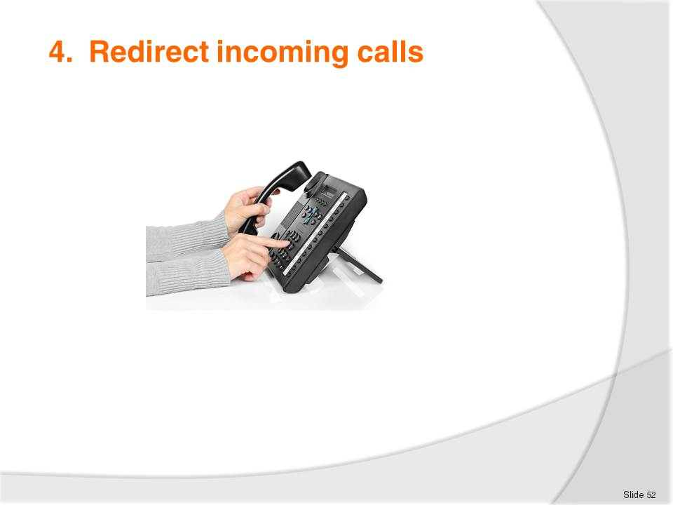
Slide No | Trainer Notes
 | Trainer to explain the idea and purpose of redirecting calls.

Slide
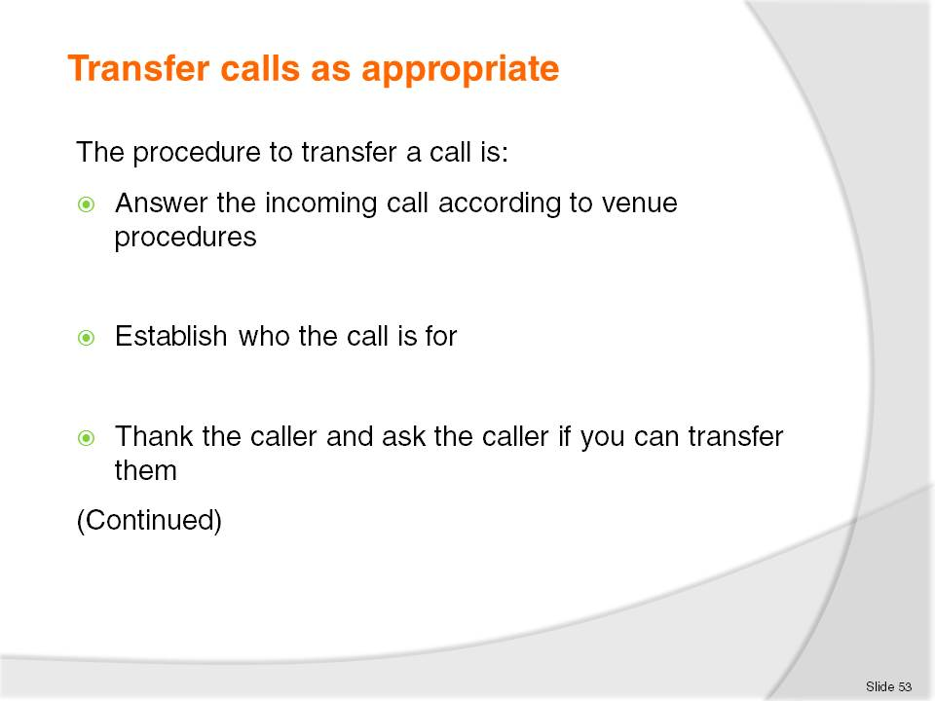
Slide No | Trainer Notes
Discuss why a call needs to be put on hold
The procedure to transfer a call is:
Answer the incoming call according to establishment procedures
Establish who the call is for
Thank the caller and ask the caller if you can transfer them.

Slide
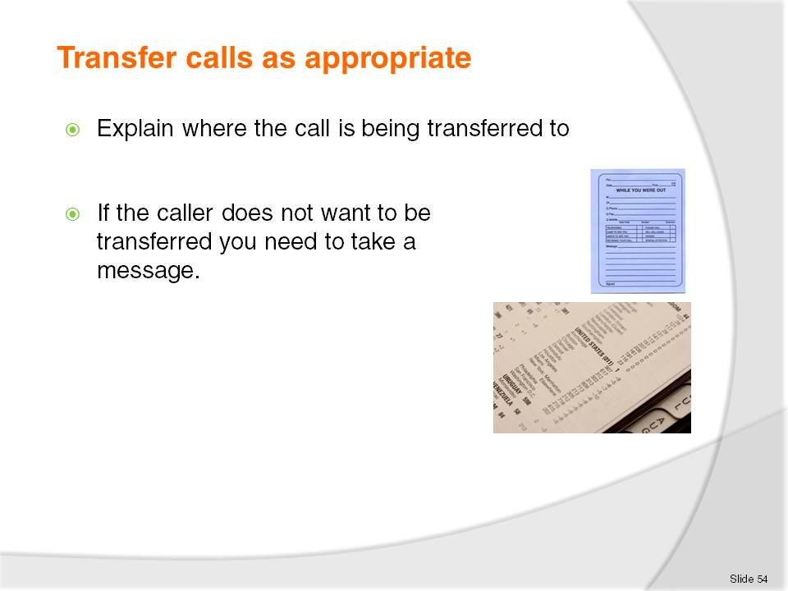
Slide No | Trainer Notes
Explain where they are being transferred to.
If the caller doesn't want to be transferred you need to take a message.

Slide
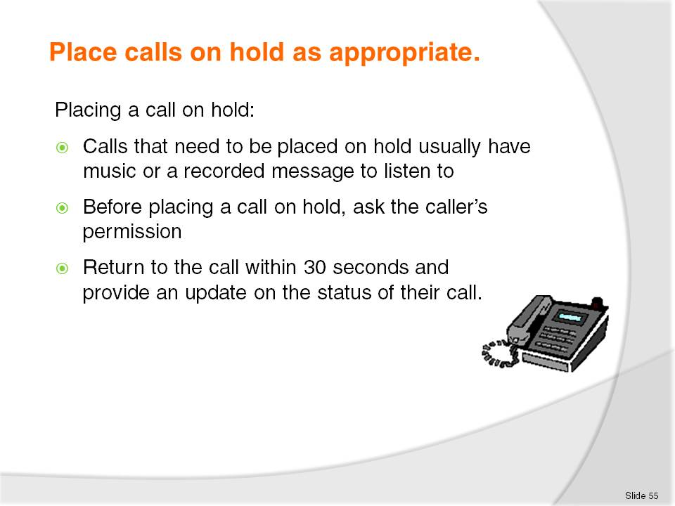
Slide No | Trainer Notes
Discuss why a call needs to be put on hold
The extension may be busy
There are several other calls to attend to at the same time
If a caller indicates that they do not want to be put on hold and ask to have the call dealt with immediately, then you may have to take information and return the call at a later time
Most telephone systems have the ability to play an advertising message or music when a call is placed on hold or before it answers
Sometimes calls are put on hold manually. For instance, when you need to get some information for the guest you will inform them that they are going to be put on hold while you collect this information or speak to a supervisor. It is good practice to advise the guest what you are doing
If a caller is on hold don’t forget to keep coming back to them to let them know what is happening. For instance, the line they are waiting for is still busy - do they want to call back or leave a message?

Recommended training equipment
- Equipment for incoming calls
- Computers with Front Office software ,currently Micros Fidelio opera Vs 5 [requires single dedicated server for Oracle ]
- Hotel plan with restaurants, leisure centre, porter area, function area etc with operating times and room types with Market segments, various rates etc
- Internet access
- Printers with various papers and templates for messages
- Fax machine
- Hotel stationary
- Telephone one per each computer
- Whiteboard, simulated Hotel Front Desk with filing system and printer and computer access for 2 computers
- Visitor information selection
- Access to hotel room with telephone, intranet and messaging system.

Instructions for Trainers for using
PowerPoint – Presenter View
Connect your laptop or computer to your projector equipment as per manufacturers’ instructions.
In PowerPoint, on the Slide Show menu, click Set Up Show.
Under Multiple monitors, select the Show Presenter View check box.
In the Display slide show on list, click the monitor you want the slide show presentation to appear on.
Source: http://office.microsoft.com
Note:
In Presenter View:
You see your notes and have full control of the presentation
Your trainees only see the slide projected on to the screen
More Information
You can obtain more information on how to use PowerPoint from the Microsoft Online Help Centre, available at: http://office.microsoft.com/training/training.aspx?AssetID=RC011298761033
Note Regarding Currency of URLs
Please note that where references have been made to URLs in these training resources trainers will need to verify that the resource or document referred to is still current on the internet. Trainers should endeavour, where possible, to source similar alternative examples of material where it is found that either the website or the document in question is no longer available online.

Appendix – ASEAN acronyms
AADCP | ASEAN – Australia Development Cooperation Program.
ACCSTP | ASEAN Common Competency Standards for Tourism Professionals.
AEC | ASEAN Economic Community.
AMS | ASEAN Member States.
ASEAN | Association of Southeast Asian Nations.
ASEC | ASEAN Secretariat.
ATM | ASEAN Tourism Ministers.
ATPMC | ASEAN Tourism Professionals Monitoring Committee.
ATPRS | ASEAN Tourism Professional Registration System.
ATFTMD | ASEAN Task Force on Tourism Manpower Development.
CATC | Common ASEAN Tourism Curriculum.
MRA | Mutual Recognition Arrangement.
MTCO | Mekong Tourism Coordinating office.
NTO | National Tourism Organisation.
NTPB | National Tourism Professional Board.
RQFSRS | Regional Qualifications Framework and Skills Recognition System.
TPCB | Tourism Professional Certification Board.







